Notes for the October 2021 SLO Bytes Photo Group
What is the difference between Luminar 4, Luminar AI and Luminar Neo?
https://insiders.skylum.com/posts/17076891
Wi-Fi Photo Transfer Free Software
https://www.youtube.com/watch?v=N0tmcRsvSI4
Jayegt Turntable $22.99
https://www.amazon.com/JAYEGT-Motorized-Rotating-Turntable-Photography/dp/B08K35HPJ4
Neewer Professional Photo Light Box Kit
20x20inch Adjustable Brightness Studio Photography Lighting Shooting Tent with 2 LED Light Panel
https://www.amazon.com/Neewer-Professional-Adjustable-Photography-Multi-Angle-dp-B08HHXRSW7/dp/B08HHXRSW7/ref=dp_ob_title_ce $85.99
Halo around Cursor- PC Only: https://www.fullbean.com/tutorials/cursor-highlighter.html
To demo Launch
Show Hidden Icons/
Creating a Cursor with a Halo in Linux Ubuntu
Steps for adding Cursor with Halo

(From web site)

https://www.linux.org/threads/how-to-install-a-yellow-or-red-circle-around-the-mouse-pointer.29509/

“That AskUbuntu post seems to work. The answer about halfway down the page titled Highlight Pointer Using Cursor Themes.
I went to https://www.gnome-look.org/p/999801/ and downloaded the bDMZ cursor theme - extracted the contents into an empty folder - and then opened /usr/share/icons as root and dragged and dropped the ybDMZ folder into the /usr/share/icons folder. There are about 6 other folders of differing cursor colors to choose from. The ybDMZ is the yellow one.

By golly - it worked!
Attached is a screen shot. See if this is what you were looking for.”

Sutter Work Flow for Halo in Linux Ubuntu
I downloaded https://www.gnome-look.org/p/999801/ and extracted it in the Downloads folder
Then I opened the Terminal and typed sudo caja
That opened Caja with me as a Superuser.
NOTE: To use Caja as a Superuser so that you can manipulate files
Open Caja from the Terminal with the command sudo caja

I navigated to the Downloads where I had extracted the files.
I then copied them to the folder usr/share/icons
In order to use them, I typed Appearance in the Mate search window
I then chose Customize/Pointer and picked the cursor with a halo that I wanted
Here is the result

View camera screen simultaneously on external monitor
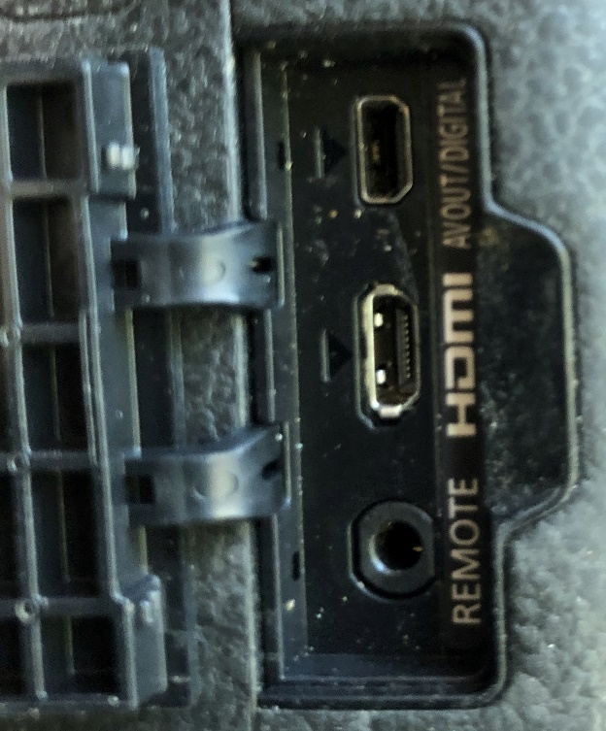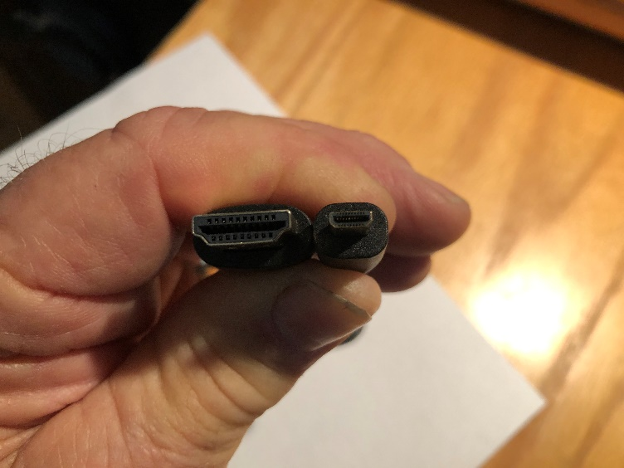
HDMI Micro Output Jack on Camera HDMI Standard and HDMI Micro Connectors
Ralph Sutter

