**SLO Bytes HardCopy  
A publication of the San Luis Obispo PC Users’ Group  
Vol. 37 No.1 January 2021**

**December 6th 2020 First Session Notes** *by Alan Raul*

APC Back-UPS  
<https://www.apc.com/shop/us/en/categories/power/uninterruptible-power-supply-ups-/computer-and-peripheral/back-ups/N-1nzwthz>

<https://www.apc.com/shop/us/en/products/APC-Back-UPS-BE850M2-850VA-2-USB-charging-ports-120V/P-BE850M2>

<https://www.apc.com/shop/us/en/products/APC-Back-UPS-BE600M1-600VA-120V-1-USB-charging-port/P-BE600M1>

Watch shows and read books for FREE  
Some AVOD Services (ad-supported video on demand) include: Crackle, IMDb TV, Popcornflix, Tubi, Vudu and YouTube.Example: James Bond 21 Full length videos  
YouTube.  
Example: James Bond 21 Full length videos  
<https://www.youtube.com/playlist?list=PLwwhtOnMyjuyEeWvv6UX11aw3jFLFAxU1>   
<https://www.overdrive.com/>

Reducing the size of a video file:  
HandBrake - The open source video transcoder  
<https://handbrake.fr/>

VLC media player  
<https://www.videolan.org/vlc/>

**▫▫▫▫▫▫▫▫▫▫▫▫▫▫▫▫▫▫▫▫▫▫▫**

**Second Session Notes** by *Alan Raul*

Google Photos will drop free unlimited storage on images and videos on June 1, 2021  
Google said any uploads after June 1, 2021, will count toward the 15GB of storage available with every Google account.  
Google confirmed that current photos and videos already on the service or added before the June 1 date will not count toward the 15GB limit.

FREE unlimited photo storage is a thing of the past.  
Amazon Photos  
Apple iCloud  
Dropbox  
Google  
Flickr/SmugMug  
Hard drives

WE ARE B&H - Get to know the people who know your gear best B&H is not a big box store, or a faceless chain… or a personality-free zone. B&H is a group of people who are passionate about the things you’re passionate about—from photography and film to music and art to technology and creating and imagining.  
<https://www.bhphotovideo.com/l/who-we-are>

ACD Systems - ACDSee Photo Studio Software - Photo Editing, Photo Management, Photo Editor, Digital Photography, Digital Asset Management, and more.  
<https://www.acdsee.com/en/index>   
ACDSee Subscription Plans  
<https://www.365.acdsee.com/>

**Alan Raul**

***▫▫▫▫▫▫▫▫▫▫▫▫▫▫▫▫▫▫▫▫▫▫▫***

**January 3rd Program** *by Ralph Sutter*

The **First ZOOM Session** will feature **Alan Raul** offering a Questions and Answers program from 12:45-2:00 p.m.

To be part of the virtual meeting via **Zoom**, please refer to the e-mail that will be sent to you twice shortly before the meeting with the credentials necessary to join the Zoom session. If you are asked for a **Meeting ID** or a **Password**, copy it from the announcement and paste it into the appropriate box

Usual topics include security issues, recent changes in Windows operating systems, tablets and smart phones as well as demos of software and hardware. We always encourage questions and observations from the audience.  
  
There will be a break from 2:00-2:30 pm allowing the audience to sip a beverage, pet the dog or stretch

The **Second Session** will offer short presentations by **Earl Kaplan**, **Kaye Raul** and **Ralph Sutter**. Each will offer a 15-20 minute talk on software that they use regularly, keeping in mind the appeal that free software has for many of our members.

Contact Ralph at [ralph@rsutter.com](mailto:ralph@rsutter.com) for more information

View Zoom tutorials at <https://www.youtube.com/playlist?list=PLKpRxBfeD1kEM_I1lId3N_Xl77fKDzSXe> If you have any questions, please contact [ralph@rsutter.com](mailto:ralph@rsutter.com)   
  
**Ralph Sutter**

**▫▫▫▫▫▫▫▫▫▫▫▫▫▫▫▫▫▫▫▫▫▫▫**

**Treasury Report by Kaye Raul**

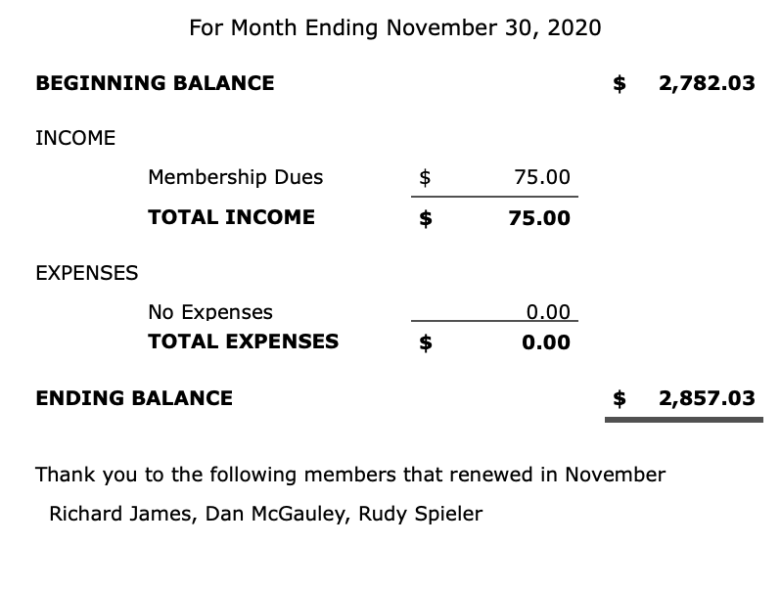

**Kaye Raul, Treasurer**

**Photo Group Report** *by Ralph Sutter***Notes from the Meeting of 12/13/2020**  
**TOPIC**: Shadows; One step behind. The meeting took place via Zoom

**Doug Depue** opened the meeting calling attention to numerous sources he compiled regarding Light and Shadow. View them on the Links Page (See 12/13/2020).

Doug then shared many images that he found on line illustrating the play of light and shadow.

**Ralph Sutter** followed with photos displaying shadows from both natural and artificial light.

**Stanford Brown** offered images in which shadows on faces and on landscapes added interest.

**John Waller** showed the play of shadows outside his home and on surrounding crops.

**Alan Raul** caught the shadows cast by a Juniper bush on the chimney of his mother's house. He also provided a link to more of his images here (See 12/13/2020).

**Bob Styerwalt** followed shadows around his house, inside and out.

**Linda Styerwalt** captured the shadows cast by a Christmas ornament.

**Kaye Raul** found shadows in the sand at several local beaches.

**Bob Ward** explored the shadows cast by vertical blinds before venturing out to the shadows of the Grand Canyon.

Our next meeting will take place on **January 10th.** The topic is **Water**. Hopefully the seasonal rains will take the hint and provide our group with many options to capture images of rain. A Zoom invitation will be e-mailed to Photo Group members shortly before the meeting.

**Ralph Sutter**

***▫▫▫▫▫▫▫▫▫▫▫▫▫▫▫▫▫▫▫▫▫▫▫***

**Push Library**  
Look at the **PUSH archives**, <http://www.slobytes.org/push/>. This is a repository of articles where you will find tips, product reviews, and personal recommendations contributed by computer clubs across the country.  
They are provided courtesy of the Association of Computer User Groups, **APCUG**, the national organization with which SLO Bytes is affiliated.   
  
The actual **PUSH** articles are hyperlinked from the index located at  
 <http://www.slobytes.org/push/index.html> (All articles on one long page)  
 <http://www.slobytes.org/push/push-condensed.html> (Links to **PUSH** articles by month received)  
You can view additional APCUG publications here: <http://www.slobytes.org/apcug/index.html>

***▫▫▫▫▫▫▫▫▫▫▫▫▫▫▫▫▫▫▫▫▫▫▫***

**SLO Bytes Bulletin Board**  
Everyone can read the SLO Bytes Bulletin Board at <http://slobytes.org/smf/index.php?board=1.0> but only subscribers can post comments or respond to the posts of others. Despite the usual connotation of **subscribe**, it costs nothing to join the bulletin board. It is free to all current SLO Bytes members. However, to guard against cyber-mischief by spammers and other ne’er-do-wells, I have disabled self-registration. If you want to be added to the bulletin board, please send your request to me at [ralph@rsutter.com](mailto:ralph@rsutter.com).

If you are currently registered with the SLO Bytes Bulletin Board and wish to change your password, you will find a video screen capture of how to do so at   
<http://www.slobytes.org/documents/change-bb-password.mp4>

***▫▫▫▫▫▫▫▫▫▫▫▫▫▫▫▫▫▫▫▫▫▫▫***

**Club Information and Meeting Times**

**SLO** **Bytes**, a PC Users Group dedicated to educating its members in the use of personal computers, digital devices and software, meets on the first Sunday of each month via **Zoom**. Zoom credentials are sent to members twice shortly before each meeting. If you are a SLO Bytes member and don’t receive this e-mail, please contact [ralph@rsutter.com](mailto:ralph@rsutter.com).

All meetings are open to the public at no cost. A general interest and Q&A session occurs from 12:45 PM to 2:00 PM and guest speaker presentations begin at 2:30 PM. Contact **Ralph Sutter** ([ralph@rsutter.com](mailto:ralph@rsutter.com)) or visit [slobytes.org](http://www.slobytes.org/index.php) for additional information about SLO Bytes and the scheduled presentation. All ideas for speakers or presentation subjects are welcome.  
 **HardCopy** is a monthly publication of **SLO Bytes PC Users' Group** located in San Luis Obispo, California. Information in this newsletter is derived from both our own membership and other PC user group newsletters.

The purpose of this publication is to inform our members of meetings and provide information related to the use of PCs and various operating systems.  
Membership dues are $25 per year. Membership entitles you to our monthly newsletter via e-mail, technical assistance comradeship and a voice in the affairs of the club.

***▫▫▫▫▫▫▫▫▫▫▫▫▫▫▫▫▫▫▫▫▫▫▫***

***Outside Special Interest Groups (SIGs)*  
The Linux Group** normally meets via Zoom at 6:30 PM on the first Thursday of the month.

View the web site at [www.slolug.com](http://www.slolug.com). Contact [Alan@alanraul.com](mailto:Alan@alanraul.com) for credentials to join the Zoom Session.  
**The Photography Group** normally meets via Zoom at 2:00 PM on the second Sunday of each month. Contact [ralph@rsutter.com](mailto:ralph@rsutter.com) for credentials to join the Zoom Session.  
Visit the website at [www.slobytes.org/digital](http://www.slobytes.org/digital)

***▫▫▫▫▫▫▫▫▫▫▫▫▫▫▫▫▫▫▫▫▫▫▫***

***SLO Bytes Officers/Volunteers*Officers**Earl Kaplan – President: [earlkaplan@gmail.com](mailto:earlkaplan@gmail.com)   
John Waller - Vice President; Programs Chair/Publicity: [johnlwaller@sbcglobal.net](mailto:johnlwaller@sbcglobal.net)   
Kaye Raul – Treasurer; Membership: [kaye@kayeraul.com](mailto:kaye@kayeraul.com)   
Ralph Sutter – Secretary, Webmaster/HardCopy Editor, Photo SIG Leader: [ralph@rsutter.com](mailto:ralph@rsutter.com)   
Alan Raul – Training Officer/Linux Group Leader: [alan@alanraul.com](mailto:alan@alanraul.com)

***▫▫▫▫▫▫▫▫▫▫▫▫▫▫▫▫▫▫▫▫▫▫▫***

**Disclaimer**: Neither SLO Bytes PC Users' Group, its officers, editors, or contributors to this newsletter assume liability for damages arising out of this publication of any article, including but not limited to the listing of programming code, batch   
files and other helpful hints. Articles from this newsletter may be reprinted by other user groups if credit is given to both   
  
the author and newsletter from which it was taken. Reproduction of articles with a specific copyright notice is prohibited without prior permission from the original author.

**SLO Bytes Website**: [slobytes.org](http://www.slobytes.org/index.html)