**SLO Bytes HardCopy  
A publication of the San Luis Obispo PC Users’ Group  
Vol. 38 No. 2 February 2022**

**January2nd 2022 First Session Notes** *by Alan Raul*Digital Photography best practices and workflow. An ASMP initiative funded by the Library of Congress. <https://dpbestflow.org/>

The 3-2-1 Rule <https://dpbestflow.org/node/262#321>

The San Luis Obispo Camera Club (SLOCC) will be merging with the Central Coast Photographic Society (CCPS) on January 1, 2022. <http://www.slocameraclub.org/> <http://centralcoastartistscollective.org/Photo%20Society.html>

CAT5E VS CAT6 VS CAT7 VS CAT8 – WHICH ONE SHOULD YOU CHOOSE?   
<https://www.telco-data.com/cat5e-vs-cat6-vs-cat7-vs-cat8/>

Making a Hard Drive Unreadable <https://asktimgrey.com/2021/12/06/making-a-hard-drive-unreadable/>   
For example, let’s assume you have a drive with drive letter Z: assigned to it, and you wanted to use four passes to overwrite the drive.  
You would use this command at the Command Prompt: Format Z: /P:4

Anker’s four-port 120W power brick is built for the USB-C warrior

<https://www.theverge.com/2021/12/23/22852051/anker-usb-c-4-port-120w-power-brick-547-charger>

<https://www.amazon.com/dp/B09J1XTLJ6>

diagrams.net - is an open-source technology stack for building diagramming applications, and the world’s most widely used browser-based end-user diagramming software. – Janet Thatcher <https://www.diagrams.net/>

Mail Merge with Microsoft Word – Ralph Sutter <https://youtu.be/T17SvLx5b40>

Create labels with a mail merge in Microsoft Word  
<https://support.microsoft.com/en-us/office/video-create-labels-with-a-mail-merge-in-word-4aa597cc-5a81-43fd-b829-9f50d54f5ef7>

**Alan Raul**

**February 6th, 2022 Program** *by Ralph Sutter*

The **First ZOOM Session** will feature **Alan Raul** offering a Questions and Answers program from 12:45-2:00 p.m.  
Usual topics include security issues, recent changes in Windows operating systems, tablets and smart phones

as well as demos of software and hardware. We always encourage questions and observations from the audience.

To be part of the virtual meeting via **Zoom**, please refer to the e-mail that will be sent to you twice shortly before the meeting with the credentials necessary to join the Zoom session. If you are asked for a **Meeting ID** or a **Password**, copy it from the announcement and paste it into the appropriate box

There will be a break from 2:00-2:30 pm allowing the audience to sip a beverage, pet the dog or stretch

The **Second Session will continue with the format begun recently. Speakers will be members of the SLO Bytes audience. Afterwards, everyone is invited to pose computer issues that they face and/or solutions to them. We will call this segment Potpourri.**

Contact Ralph at [ralph@rsutter.com](mailto:ralph@rsutter.com) for more information

View Zoom tutorials at <https://www.youtube.com/playlist?list=PLKpRxBfeD1kEM_I1lId3N_Xl77fKDzSXe> If you have any questions, please contact [ralph@rsutter.com](mailto:ralph@rsutter.com)   
  
**Ralph Sutter**

**▫▫▫▫▫▫▫▫▫▫▫▫▫▫▫▫▫▫▫▫▫▫▫**

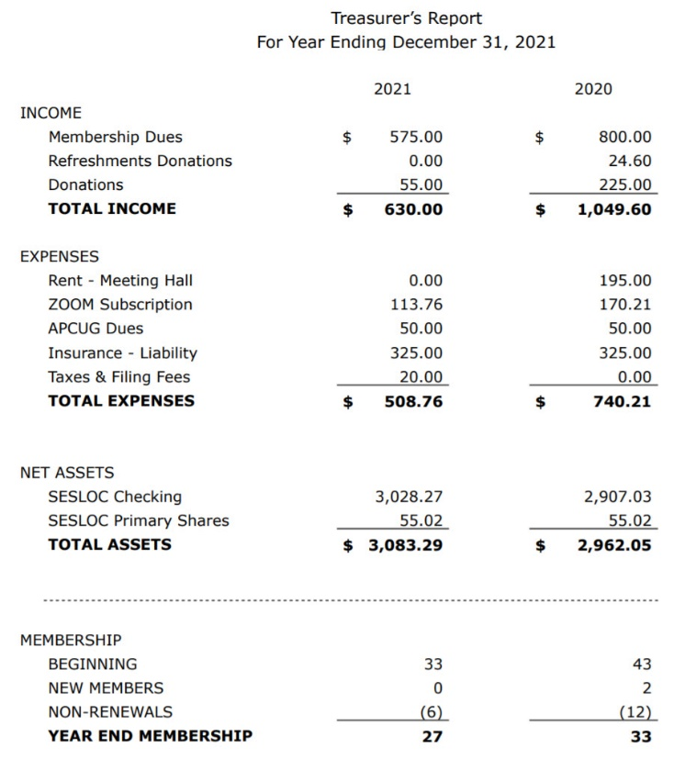**Treasury Report by Kaye Raul**

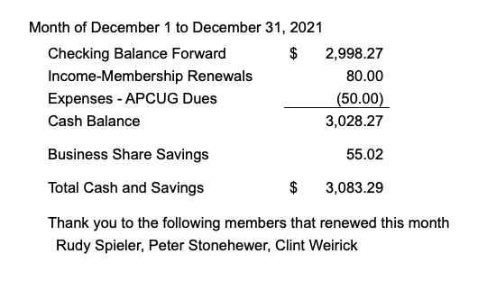

**Kaye Raul**

**Photo Group Report** *by Alan Raul***Notes** from the Meeting of 01/09/2022  
**TOPIC**: Leisure Time; Share images relating to what we do for fun  
  
**Kaye Raul** shared shots of people enjoying sunsets with dogs and loved ones at Shell Beach. She followed with shots of boating in Avila Beach and the lake at Waller Park.   
**John Waller** showed a variety of images documenting what he does in his leisure. These includes shots of classic books, boats and more.   
**Alan Raul** showed images from around Shell Beach coastline which documented "King Tides" shot over a period of three days in the mid-morning and late afternoon. A "King Tide" is a popular, non-scientific term people often use to describe exceptionally high tides. With the high tides come exceptionally low tides. These images were captured with a Sony A7II w/a 24 - 70mm F4.0 lens.   
  
The second session dealt with **Aurora HDR** being used as a stand-alone program vs. a **Lightroom** plug-in. Alan gave a short Aurora HDR demo. John explained file naming when using Aurora HDR as a Lightroom plug-in.   
The next meeting will take place on February 13th. The topic for the February 13th meeting is **Street photography with or without people**, shot within the last 30 days.   
The meeting will take place via Zoom.   
  
A **Zoom** invitation will be e-mailed to Photo Group members shortly before the meeting Here is the tentative meeting schedule for 2022   
   March 13   
   April 10   
   May 15 (due to Mothers' Day on May 8th)   
   June 12   
   July 10   
   August 14   
   September 11   
   October 09   
   November 13   
   December 11

See the Links page for tutorials and other resources

**Alan Raul**

**▫▫▫▫▫▫▫▫▫▫▫▫▫▫▫▫▫▫▫▫▫▫▫**

**Push Library**  
Look at the **PUSH archives**, <http://www.slobytes.org/push/>. This is a repository of articles where you will find tips, product reviews, and personal recommendations contributed by computer clubs across the country.  
They are provided courtesy of the Association of Computer User Groups, **APCUG**, the national organization with which SLO Bytes is affiliated.   
The actual **PUSH** articles are hyperlinked from the index located at  
 <http://www.slobytes.org/push/index.html> (All articles on one long page)  
 <http://www.slobytes.org/push/push-condensed.html> (Links to **PUSH** articles by month received)  
You can view additional APCUG publications here: <http://www.slobytes.org/apcug/index.html>

**▫▫▫▫▫▫▫▫▫▫▫▫▫▫▫▫▫▫▫▫▫▫▫**

**SLO Bytes Bulletin Board**  
Everyone can read the SLO Bytes Bulletin Board at <http://slobytes.org/smf/index.php?board=1.0> but only subscribers can post comments or respond to the posts of others. Despite the usual connotation of **subscribe**, it costs nothing to join the bulletin board. It is free to all current SLO Bytes members. However, to guard against cyber-mischief by spammers and other ne’er-do-wells, I have disabled self-registration. If you want to be added to the bulletin board, please send your request to me at [ralph@rsutter.com](mailto:ralph@rsutter.com).

If you are currently registered with the SLO Bytes Bulletin Board and wish to change your password, you will find a video screen capture of how to do so at   
<http://www.slobytes.org/documents/change-bb-password.mp4>

***▫▫▫▫▫▫▫▫▫▫▫▫▫▫▫▫▫▫▫▫▫▫▫***

**Club Information and Meeting Times**

**SLO** **Bytes**, a PC Users Group dedicated to educating its members in the use of personal computers, digital devices and software, meets on the first Sunday of each month via **Zoom**. Zoom credentials are sent to members twice shortly before each meeting. If you are a SLO Bytes member and don’t receive this e-mail, please contact [ralph@rsutter.com](mailto:ralph@rsutter.com).

All meetings are open to the public at no cost. A general interest and Q&A session occurs from 12:45 PM to 2:00 PM and guest speaker presentations begin at 2:30 PM. Contact **Ralph Sutter** ([ralph@rsutter.com](mailto:ralph@rsutter.com)) or visit [slobytes.org](http://www.slobytes.org/index.php) for additional information about SLO Bytes and the scheduled presentation. All ideas for speakers or presentation subjects are welcome.  
 **HardCopy** is a monthly publication of **SLO Bytes PC Users' Group** located in San Luis Obispo, California. Information in this newsletter is derived from both our own membership and other PC user group newsletters.

The purpose of this publication is to inform our members of meetings and provide information related to the use of PCs and various operating systems.  
Membership dues are $25 per year. Membership entitles you to our monthly newsletter via e-mail, technical assistance comradeship and a voice in the affairs of the club.

***▫▫▫▫▫▫▫▫▫▫▫▫▫▫▫▫▫▫▫▫▫▫▫***

***Outside Special Interest Groups (SIGs)*The Linux Group** normally meets via Zoom at 6:30 PM on the first Thursday of the month.  
View the web site at [www.slolug.com](http://www.slolug.com). Contact [Alan@alanraul.com](mailto:Alan@alanraul.com) for credentials to join the Zoom Session.  
 **The Photography Group** normally meets via Zoom beginning at 2:00 PM on the second Sunday of each month. Contact   
  
[ralph@rsutter.com](mailto:ralph@rsutter.com) for credentials to join the Zoom Session.  
Visit the website at [www.slobytes.org/digital](http://www.slobytes.org/digital)

***SLO Bytes Officers/Volunteers*Officers**John Waller- President/Programs Chair: [johnlwaller@sbcglobal.net](mailto:johnlwaller@sbcglobal.net)  
Kaye Raul – Treasurer; Membership: [kaye@kayeraul.com](mailto:kaye@kayeraul.com)   
Ralph Sutter – Secretary, Webmaster/HardCopy Editor, Photo Group Leader: [ralph@rsutter.com](mailto:ralph@rsutter.com)   
Alan Raul – Training Officer/Linux Group Leader: [alan@alanraul.com](mailto:alan@alanraul.com)

**Advisors to the Board of Directors**  
Peter Stonehewer: blacklakepete@yahoo.com  
Jim Buenrostro: jnb33@yahoo.com

***▫▫▫▫▫▫▫▫▫▫▫▫▫▫▫▫▫▫▫▫▫▫▫***

**Disclaimer**: Neither SLO Bytes PC Users' Group, its officers, editors, or contributors to this newsletter assume liability for damages arising out of this publication of any article, including but not limited to the listing of programming code, batch   
files and other helpful hints. Articles from this newsletter may be reprinted by other user groups if credit is given to both   
  
the author and newsletter from which it was taken. Reproduction of articles with a specific copyright notice is prohibited without prior permission from the original author.

**SLO Bytes Website**: [slobytes.org](http://www.slobytes.org/index.html)