SLO Bytes HardCopy
A publication of the San Luis Obispo PC Users’ Group
Vol. 34 No. 4 April 2018
March 4th, 2018 First Session Notes by Alan Raul
GeGeek - I don’t reinvent the wheel, I just link to it.
https://www.gegeek.com/
List of Movies and TV Shows on Netflix
https://flixable.com/
JustWatch can easily find out where to watch your favorite movies & TV shows.
https://www.justwatch.com/us
VLC is a free and open source cross-platform multimedia player and framework that plays most multimedia files as well as DVDs, Audio CDs, VCDs, and various streaming protocols.
https://www.videolan.org/
LAN (Linux Action News) #41 – Mozilla Firefox and Google Chrome web browser information beginning at 3 minutes 30 seconds
http://www.jupiterbroadcasting.com/122527/linux-action-news-41/
Update on Pocket and Firefox Integration
https://blog.mozilla.org/futurereleases/2018/01/24/update-on-pocket-and-firefox-integration/
Google Launches Snapchat Stories-Like AMP Stories and AMP for Email
https://www.xda-developers.com/google-amp-stories-amp-for-email/
The Two Faces of AMP
https://timkadlec.com/remembers/2018-02-14-the-two-faces-of-amp/
The Case Against Google - Critics say the search giant is squelching competition before it begins. Should the government step in?
https://www.nytimes.com/2018/02/20/magazine/the-case-against-google.html
Alan Raul

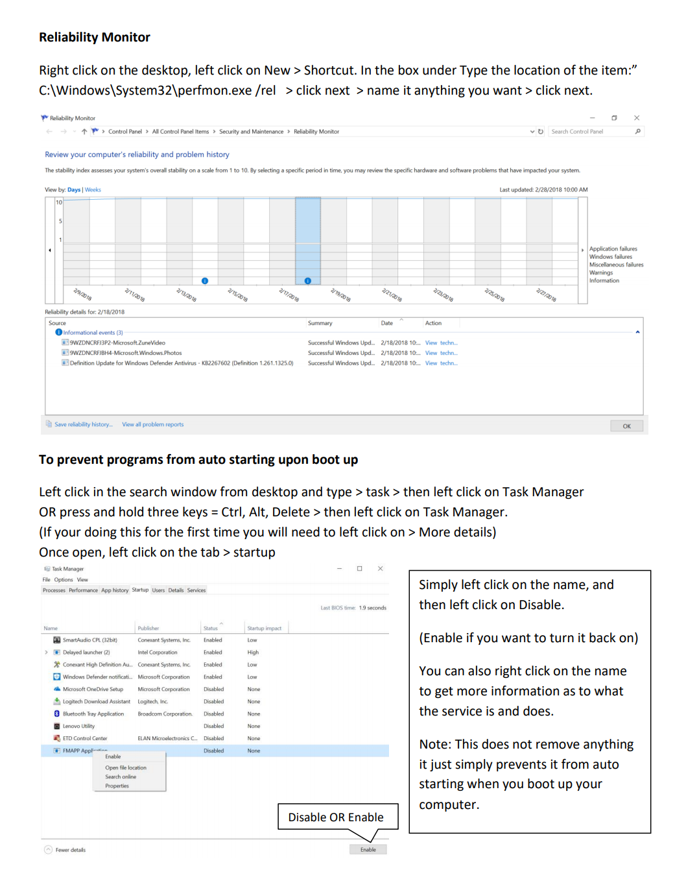
March 4th, 2018 Second Session Notes by Jim Carter
April 1st Programming Schedule by Ralph Sutter for John Waller
The First Session will feature Ralph Sutter moderating a Questions and Answers program from 12:45-2:00 p.m. Usual topics include security issues, recent changes in Windows operating systems, tablets and smart phones as well as demos of software and hardware. Ralph always encourages questions and observations from the audience.
During the break, from 2:00-2:30 pm, coffee and cookies will be offered as well as a chance for you to chat with other club members.
In the Second Session, beginning at 2:30 pm, the format will shift to an open forum in which members are encouraged to share their computer experiences, both positive and negative. This may include phones, tablets and related electronic devices. Contact Ralph Sutter at ralph@rsutter.com for more information
Ralph Sutter
▫▫▫▫▫▫▫▫▫▫▫▫▫▫▫▫▫▫▫▫▫▫▫
Treasurer’s Report for March 2018 by Bob Styerwalt
Income February 5, 2018 thru March 4, 2018
 | Renewing Members | $100.00
 | New Members
 | Refreshments donations | $20.00
 | General donations | $15.00
Guild Hall | Pre-paid rent returned to us | $650.00
Expenses:
 | Refreshments reimbursement
State Farm | Liability Insurance Premium | $325.00
Bank Statement ending 02/28/2018
 | Checking account balance | $2,635.03
 | Interest paid this period | $0.00
 | Deposits | $790.00
 | Withdrawals | $325.00
Renewing Members: Four members renewed during this period: Lawrence Green, Don Jones, Jim Middlemist and Monica Tarzier. Thanks to all for your continuing interest and support. One member made a generous donation of $15. Thank you! General donations to the club budget are always welcome and are tax deductible. As noted before, general donations will be reported anonymously in this publication unless the donor specifically requests public acknowledgement.
[Most people seem to prefer anonymity.]
I continue to believe that we have a friendly group that can provide useful information to any computer user. Please encourage your friends, neighbors, kids, parents and strangers to check us out.
Bob Styerwalt
▫▫▫▫▫▫▫▫▫▫▫▫▫▫▫▫▫▫▫▫▫▫▫
Photo Group Report by Ralph Sutter
Notes from the March 11th Session
TOPIC: Fire
The session opened with Ralph Sutter calling attention to recent postings at http://www.slobytes.org/digital/links.html, the Links page of the club web site. There, you will find a listing of 13 free photo editors.
Sutter then played a video showing fire ranging from the false fire of a realistic battery-operated candle to a birthday celebration, burn pile and wood stove.
Alan Raul followed with fire images of propane heaters in sidewalk cafes and flckering flames in a church sanctuary. He then demonstrated how applying warming filters can heighten the impact of the scene.
Kaye Raul mixed fire and smoke in her photos, explaining the challenges of capturing the latter in a way that added to the composition.
John Waller took the opportunity to share pictures of firefighting aircraft and to experiment with the Fire effect in Photoshop, setting ablaze ocean horizons and telephone wires.
Monica Tarzier showed rustic scenes illuminated by the campfire or the outdoor fire pit.
The presentations were followed by a wide-ranging discussion of image editing, image presentation and photography in general. The consensus view is that auto-advancing slide shows are more apt to be viewed in their entirity than presentations in which the viewer has to click on each image to advance the program.
Several members of the group praised the slideshow program, ProShow Gold as the premiere software for slideshow presentation..
Our next meeting will take place on Sunday, April 8th beginning at 2:00 pm. The topic will be Circles. Attendees are encouraged to bring images of all things circular.
Ralph Sutter
▫▫▫▫▫▫▫▫▫▫▫▫▫▫▫▫▫▫▫▫▫▫▫
Push Library
Look at the PUSH archives, http://www.slobytes.org/push/. This is a repository of articles where you will find tips, product reviews, and personal recommendations contributed by computer clubs across the country.
They are provided courtesy of the Association of Computer User Groups, APCUG, the national organization with which SLO Bytes is affiliated.
The actual PUSH articles are hyperlinked from the index located at
http://www.slobytes.org/push/index.html (All articles on one long page)
http://www.slobytes.org/push/push-condensed.html (Links to PUSH articles by month received)
You can view additional APCUG publications here: http://www.slobytes.org/apcug/index.html
▫▫▫▫▫▫▫▫▫▫▫▫▫▫▫▫▫▫▫▫▫▫▫
SLO Bytes Bulletin Board
Everyone can read the SLO Bytes Bulletin Board at http://slobytes.org/smf/index.php?board=1.0 but only subscribers can post comments or respond to the posts of others. Despite the usual connotation of subscribe, it costs nothing to join the bulletin board. It is free to all current SLO Bytes members. However, to guard against cyber-mischief by spammers and
other ne’er-do-wells, I have disabled self-registration. If you want to be added to the bulletin board, please send your request to me at ralph@rsutter.com.
If you are currently registered with the SLO Bytes Bulletin Board and wish to change your password, you will find a video screen capture of how to do so at http://www.slobytes.org/documents/change-bb-password.mp4
▫▫▫▫▫▫▫▫▫▫▫▫▫▫▫▫▫▫▫▫▫▫▫

Club Information and Meeting Times
SLO Bytes, a PC Users Group dedicated to educating its members in the use of personal computers, digital devices and software, meets on the first Sunday of each month at the San Luis Obispo Guild Hall at 2880 Broad Street, San Luis Obispo. There is a map available at http://www.slobytes.org/slo-guild-map.html.
All meetings are open to the public at no cost. A general interest and Q&A session occurs from 12:45 PM to 2:00 PM and guest speaker presentations begin at 2:30 PM. Contact John Waller (johnlwaller at sbcglobal.net) or visit slobytes.org for additional information about SLO Bytes and the scheduled presentation.
All ideas for speakers or presentation subjects are welcome.
HardCopy is a monthly publication of SLO Bytes PC Users' Group located in San Luis Obispo, California. Information in this newsletter is derived from both our own membership and other PC user group newsletters. The purpose of this
publication is to inform our members of meetings and provide information related to the use of PCs and various operating systems.
Membership dues are $25 per year. Membership entitles you to our monthly newsletter via e-mail, technical assistance, eligibility for raffle gifts when drawings are held, a voice in the affairs of the club, and comradeship.
▫▫▫▫▫▫▫▫▫▫▫▫▫▫▫▫▫▫▫▫▫▫▫
Outside Special Interest Groups (SIGs)
Linux SIG normally meets at 6:30 PM on the Thursday following our Sunday's General Meeting at the KCBX.NET Training Center, 4100 Vachell Lane, San Luis Obispo. View the web site at www.slolug.com.
Photography SIG normally meets at 2:00 PM on the second Sunday of each month at Ralph Sutter’s home in Arroyo Grande. Call Ralph at 478-0826 for directions. Visit the website at www.slobytes.org/digital
▫▫▫▫▫▫▫▫▫▫▫▫▫▫▫▫▫▫▫▫▫▫▫
SLO Bytes Officers/Volunteers
Officers
Earl Kaplan – President: earlkaplan at gmail.com
John Waller - Vice President; Programs Chair/Publicity: johnlwaller at sbcglobal.net
Bob Styerwalt – Treasurer; Membership: rstyerwalt at gmail.com
Ralph Sutter – Secretary, Webmaster/HardCopy Editor, Photo SIG Leader: ralph at rsutter.com
Alan Raul – Training Officer: alan at alanraul.com
Other Volunteers
Nancy Vrooman – Refreshments
Peter Stonehewer – Refreshments
Ken Stilts – Set-up/Clean-up
▫▫▫▫▫▫▫▫▫▫▫▫▫▫▫▫▫▫▫▫▫▫▫
Disclaimer: Neither SLO Bytes PC Users' Group, its officers, editors, or contributors to this newsletter assume liability for damages arising out of this publication of any article, including but not limited to the listing of programming code, batch
files and other helpful hints. Articles from this newsletter may be reprinted by other user groups if credit is given to both the author and newsletter from which it was taken. Reproduction of articles with a specific Copyright notice is prohibited without prior permission from the original author.
SLO Bytes Website: slobytes.org

