News Sources and Objectivity
What I use
AP News: https://www.apnews.com/ (My first choice for on-line news)
The Skimm: https://theskimm.com/recent (light weight irreverent sampling of news)
Telegram Tribune: http://digital.olivesoftware.com/Olive/ODN/SanLuisObispo/default.aspx? (Easier to read on line than walk to my rural mailbox; Online app is free to subscribers of the printed version)
How to Detect Bias in News: https://fair.org/take-action-now/media-activism-kit/how-to-detect-bias-in-news-media/
Reviews of News Services for Windows 10: https://www.windowscentral.com/best-news-apps-windows-10
Microsoft Store: News and Weather: https://www.microsoft.com/en-us/store/top-free/apps/pc?category=news+%26+weather%5Cnews
Reviews of News Services for Smart Phones: https://www.digitaltrends.com/mobile/best-news-apps/
Alternative News: Moon Landing Faked;
Wikipedia: https://en.wikipedia.org/wiki/Moon_landing_conspiracy_theories
Fox News Documentary; https://www.youtube.com/watch?v=MIy8ZqqK5G8
Flat Earth Theory: http://freedom-articles.toolsforfreedom.com/2nd-biggest-conspiracy-flat-earth/

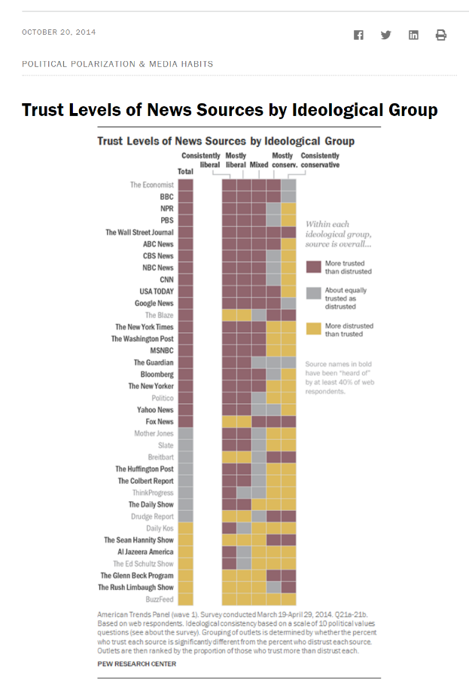

Source: http://www.journalism.org/2014/10/21/political-polarization-media-habits/pj_14-10-21_mediapolarization-01/

Pew Report - Political Polarization and Media Habits Final Report 7/27/15
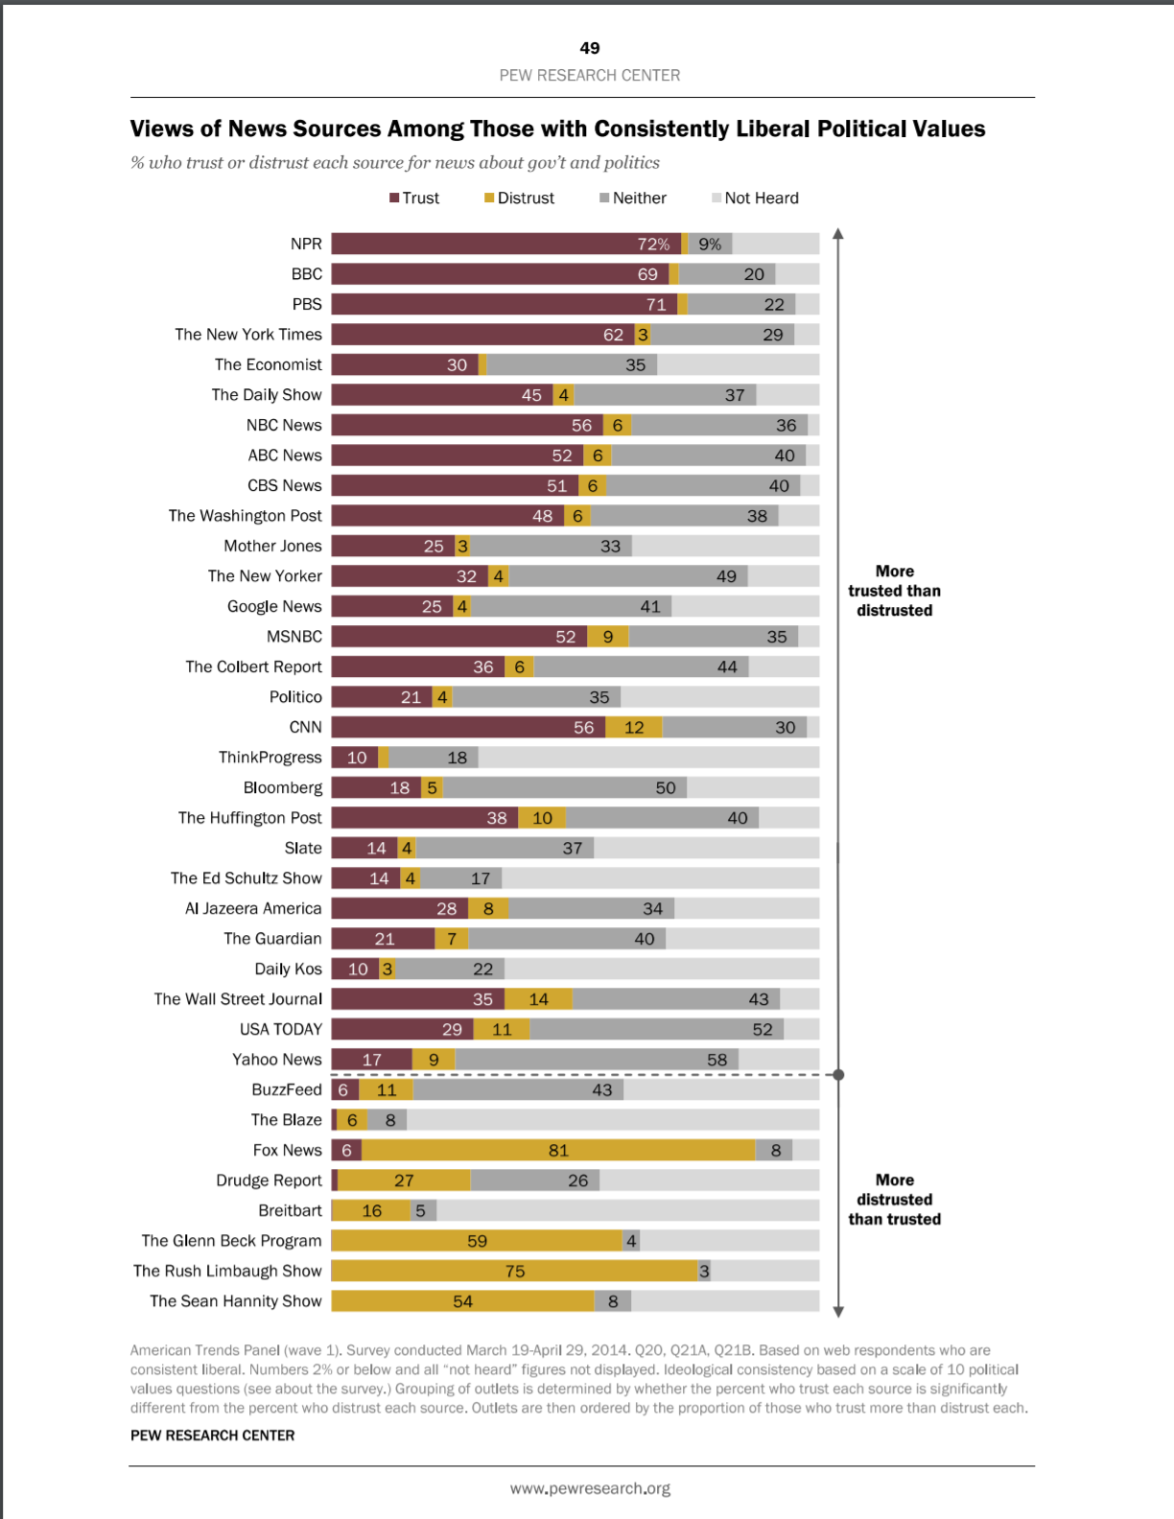 | 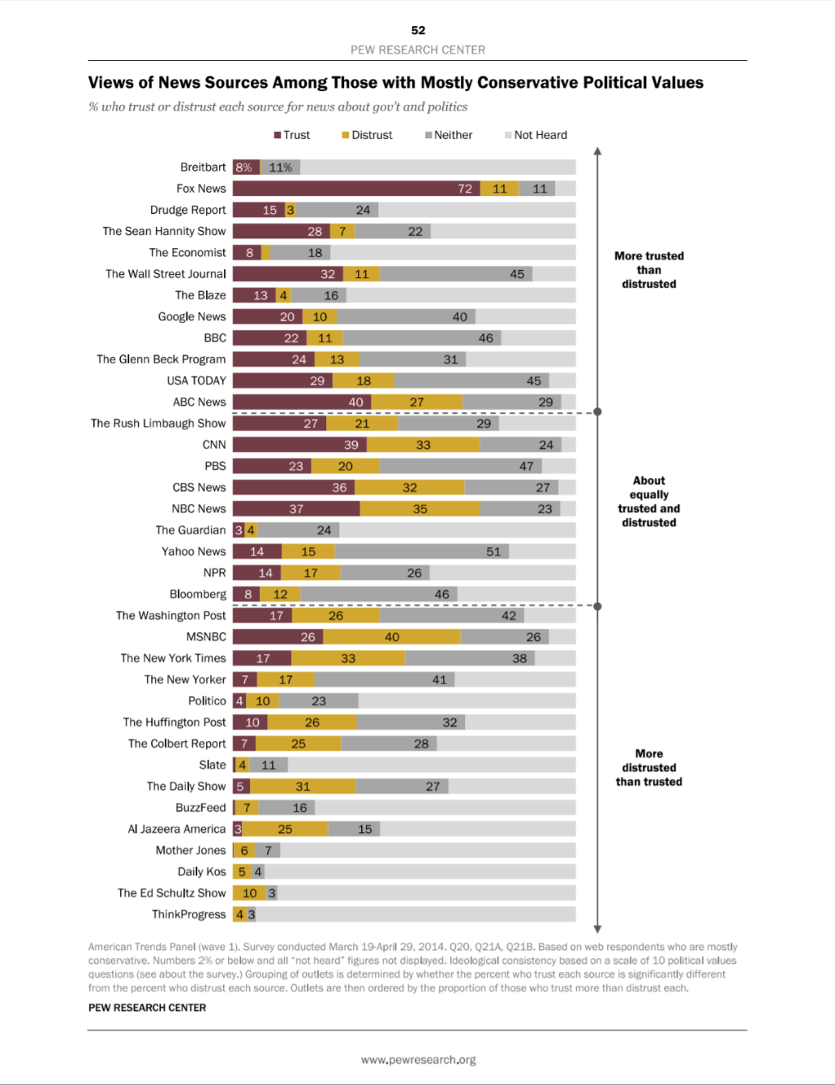
Source: http://assets.pewresearch.org/wp-content/uploads/sites/13/2014/10/Political-Polarization-and-Media-Habits-FINAL-REPORT-7-27-15.pdf

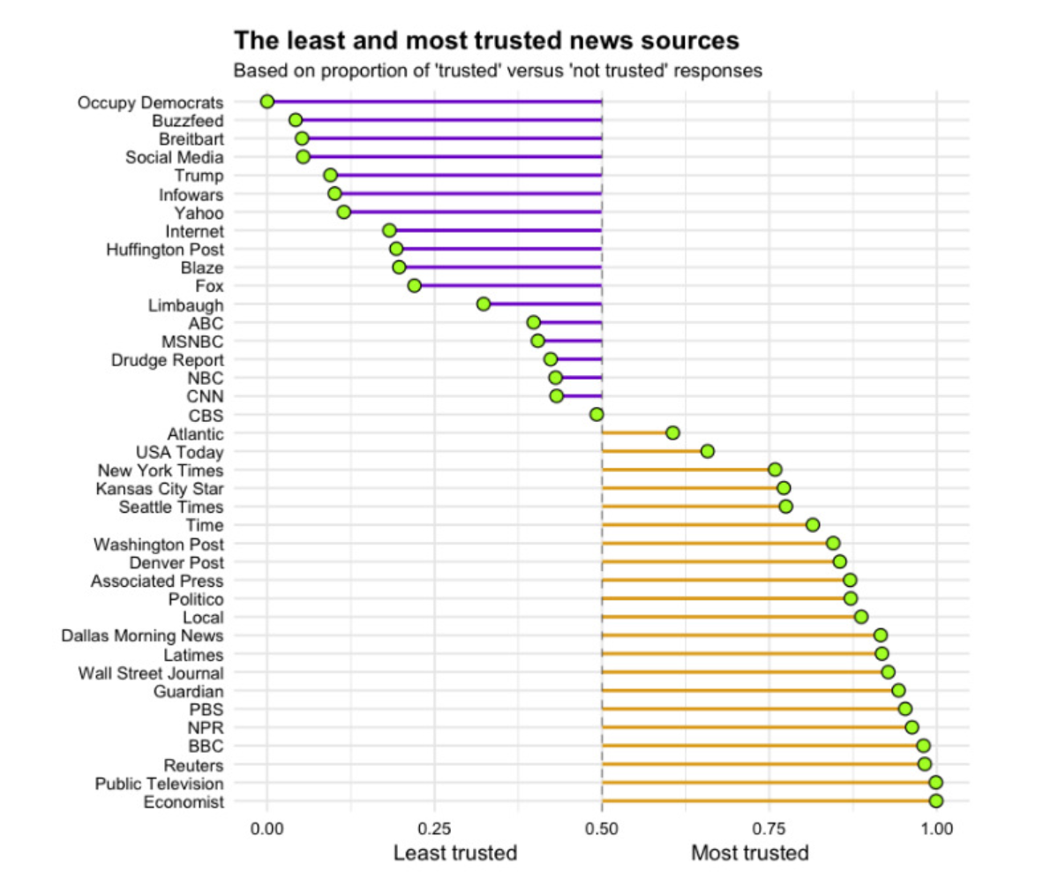
Source: http://www.visualcapitalist.com/least-most-trusted-news-sources/

13 Most Trusted News Sites that You Should Bookmark
Source: https://www.makeuseof.com/tag/trust-news-sites/

Associated Press News
BBC
Brief.news
The Bureau of Investigative Journalism
The Christian Science Monitor
The Economist
NPR
ProPublica
Reuters
USA Today
The Wall Street Journal
FAIR

Smartphone Alerts
Source: https://www.makeuseof.com/tag/4-ways-to-keep-up-with-breaking-news-online/

One of the easiest ways to keep up with breaking news online is to have it pushed directly to your phone. There are a ton of apps out there that make that easier than ever. No matter your preferred news source, you’re likely to find a native app that delivers breaking news updates as push notifications to your phone. Below is just a sample list of the most prominent mobile apps (Android, iPhone, Windows and Blackberry) that deliver news updates as push notifications:
AP Mobile
CNN
Breaking News
Fox News
Reuters
BBC News
Some news services also provide news alerts via text message, including CNN, BBC, Al Jazeera, Sky News and NBC News. The service’s availability might vary according to the country you live in.
USA Today
CNN
Fox News
If you don’t want to limit yourself to one news service, you can always create custom breaking news alerts on any topic of your choice using Google or Yahoo Alerts — that way you’re ensuring that you’re getting lots of different angles to one story, rather than sticking to one,

PLEX Newsfeed

https://app.plex.tv/desktop#!/provider/tv.plex.provider.news

Off line link to above; http://www.slobytes.org/presentations/sutter-0818/plex.mp4

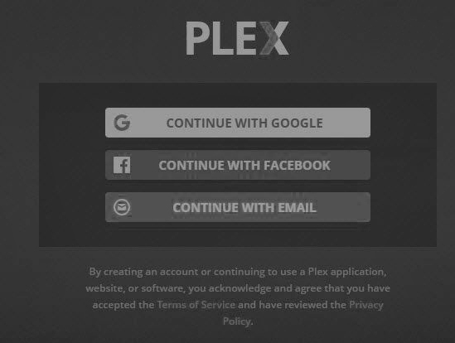
PLEX Sign-up Agreement

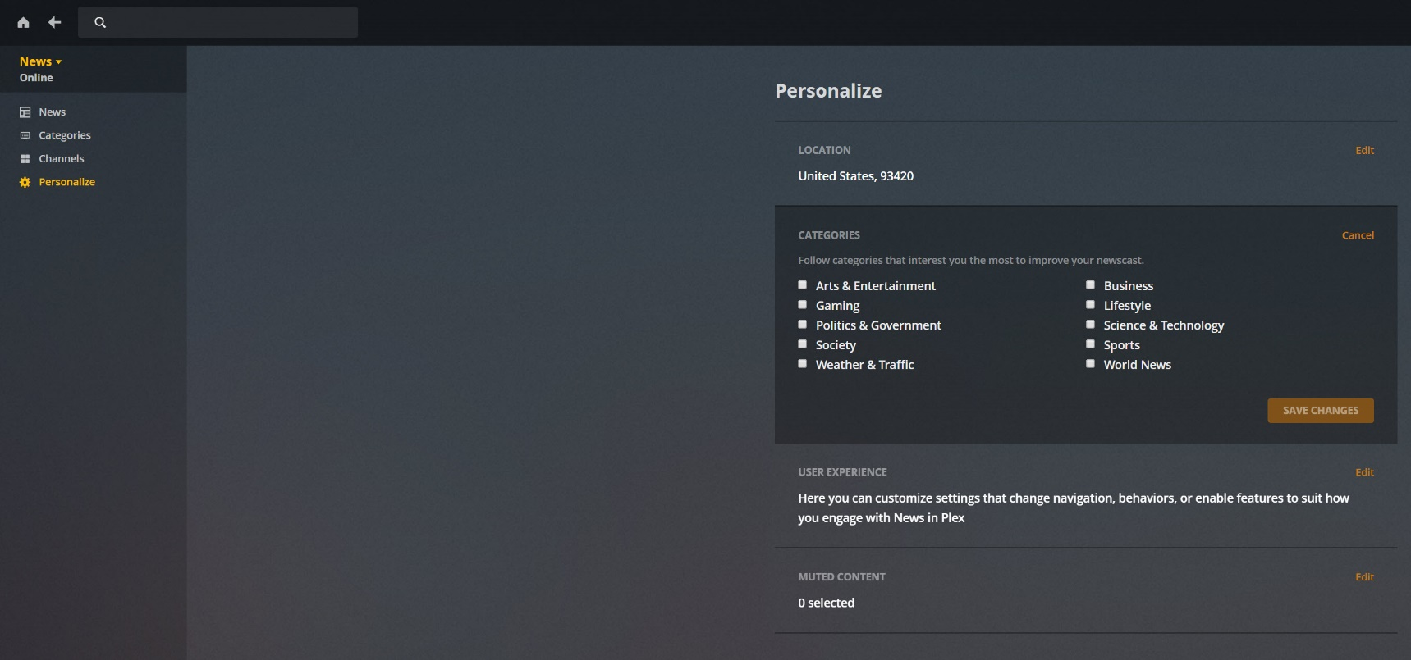
Personalization Options

PLEX Channels
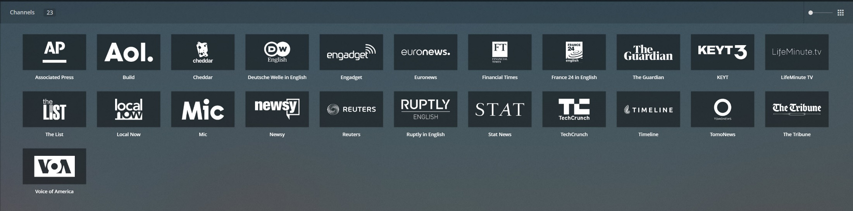
https://app.plex.tv/desktop#!/provider/tv.plex.provider.news?key=%2Flibrary%2Fsections%2Fchannels&context=content.channels

Ralph Sutter

