(Approx. 3215 words)

Software Review - Topaz Photography Collection, Part 1
By Mark Mattson, Computer Users of Erie
www.cuerie.com
cuerie01 (at) roadrunner (dot) com

Topaz Labs is a small, privately-owned company based in Dallas and Austin Texas. Founded in 2005, it offers high quality image editing tools used by numerous photographers worldwide, both amateur and professional alike.

The Topaz Photography Collection is a bundle of 16 products, all designed to make your image editing and enhancements faster and easier. All are plug-ins that work inside your image editing software, with the exception of Topaz Glow, Impression and photoFXlab, which operate as stand-alone products.

This review will be split into four parts, to be published in the upcoming issues of their newsletter from August until November. It will be a brief overview of each product, giving sample images to illustrate how each plug-in enhances your image. Be aware, however, that these products are very high quality and contain a lot of ways to manipulate your photos. To cover them all would take a long time, and most likely would result in a very lengthy book instead of a newsletter. I’m hoping to give you all a glimpse into what you can do with these products, and how to apply them to your work.

The kind sales department at Topaz has set up a discount code for your use, which is valid only until September 30, 2015. It will give you a 15% discount on your entire cart if you decide to purchase the bundle, or even just a few of the components. If you see something you like, and want to use it for your future work, this can save you some money. The discount code is APCUG15.

There is a 30-day unlimited trial for each of the bundle components, so you can try them before purchasing to see how they work. You can use them just as if you bought the license, and save images without any type of watermark.

This way, you can use your own photos, without incurring an up-front expense. If you like it, purchase the license. If not, you aren’t out anything.

System Requirements

Topaz products run on both the Mac and Windows platforms. However, you need to have an Intel-based Mac as they will NOT run on a PowerPC-based system.

Some of the products will run on systems with 32-bit processors and 2GB of RAM, while others require a 64-bit CPU and a minimum of 4GB memory. It also appears that the Mac users will need to be running a 64-bit CPU.

To simplify the requirements, I would recommend you to be running a 64-bit CPU and operating system, with a bare minimum of 4GB memory installed. More RAM will be better, as it will allow the plug-ins to operate faster and more efficiently.

You also should have OpenGL3.2 on your PC system for best operation. You can check this by looking at your video card / driver specs on the card manufacturer’s website.

Windows 7 or above, or Mac OS-X 10.8 or above are the recommended operating systems for the Topaz plug-ins. Again, a 64-bit version is best, especially for the Mac platform. Many of their products need 64-bit systems to operate.

You can find links to the official Topaz requirements on this page: http://www.topazlabs.com/downloads
Look on the right column to find the links to the requirements for the products. You will also find a link to the page listing compatible host programs (your image editor). As I noted earlier, Topaz products will work with Photoshop, Photoshop Elements, and Lightroom (with an additional download). Some have reported success using them with GIMP and Serif’s PhotoPlus, as well as Irfanview and Corel’s Paintshop Pro and Photoimpact. Be sure to check out the notes for your particular image editor to see how to access the plug-ins.

Installation

When you purchase any of the Topaz products, or the bundle, they are delivered via electronic download direct to your computer. The license key comes with your confirmation email. The only exception to the bundle is that Topaz Glow and Impression are separate downloads. Perhaps at some future point they will be incorporated into one download, but for now, you’ll need to download them separately. Additionally, those two products come with their own license code. The rest of the bundle uses one common code for activation.

As I am a PC user, I am not familiar with the installation procedures for the Mac platform, but I would imagine they are somewhat the same as for installing other applications. For Windows users, you double-click the installer files, and follow the prompts to install the plug-ins. I chose all default selections for prompts, and installation went without a hitch. In only a few minutes they were ready for use.

One word of caution: the complete bundle is a file that is a bit over 821 MB in size. If you have a slow Internet connection, it can take some time to download the package. Allow sufficient time for it to download, perhaps overnight if you have a really slow DSL or cable connection. Glow and Impression are much smaller files, and will take significantly less time to download.

Remember that these are plug-ins for a host editing program. There will not be any icons created on your desktop, with the exception of Topaz Glow, Impression and photoFXlab. These last three can be used stand-alone, so icons will be created during installation.

If you have any issues with installation, Topaz has help topics available online if needed. Their Help Center may be found on the following page:
https://support.topazlabs.com/hc/en-us

The User Guides for the plug-ins are available online as PDF files. They contain installation instructions for getting them into your host editor software, and explain the operation of the adjustment controls for that particular product. You can find them on this page:
https://support.topazlabs.com/hc/en-us/sections/200398443-User-Guides

With these preliminaries out of the way, it’s time to take a look at the components found in the Complete Photography Collection.

Topaz Adjust

Always remember that, no matter how good, expensive or sophisticated the camera and lenses you use, or your shooting technique, your eyes will always be able to see more detail in any given scene. Both digital as well as film-based photography are limited by the technologies involved in the process of creating a photograph.

This is evident (sometimes painfully) when looking at the photos you captured on a shoot. The bright colors, contrast, and perhaps even many of the details that you saw when looking at the scene are reduced or even missing from your captured photo. They may look dull and lifeless, nothing like what you saw when looking at it with your eyes.

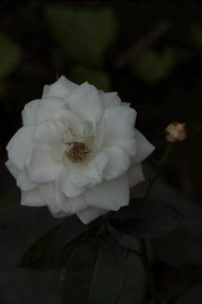
Topaz Adjust is designed to aid in recovering those elements that the camera could not capture like your eyes could. With this tool, you can bring back lost details, enhance the contrast of the scene, and make the colors pop to bring the image back to life.

As an example, the image to the left is an image I shot while getting used to my Canon 70D camera. As I was still experimenting with it, I was not getting satisfactory images due to incorrect settings. As you can see, the image is dark and low in contrast, definitely not suitable for any type of use.

Thinking that this would make a good test image for Adjust, I loaded it into Photoshop and launched the plug-in.

Topaz has designed their plug-ins to have as similar an interface as possible between all plug-ins, so as to make it easier to work with them. The following image shows the poorly exposed image open in the Adjust workspace.

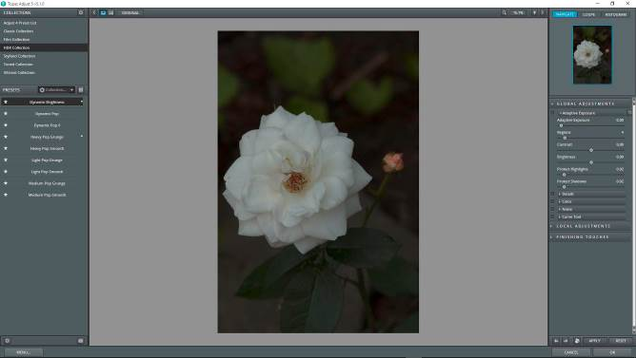

The left column contains a list of Preset collections, with the contents of each collection shown immediately below. The preview window is in the center, while the right column contains tools specific to each plug-in that allow you to customize a preset, or to adjust image parameters manually to get the look and feel you desire.

For this image I chose to use one of the presets found in the HDR collection. Immediately above the list of presets is an icon that allow you to switch to a grid view, showing you thumbnails of your image with each preset applied to it. This can make it easier to choose which one you’d like to apply.

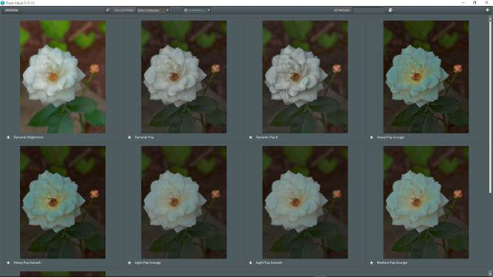
You can click on one of the thumbnails to select it and return to the main view. From there you can further refine your image using the sliders and controls in the right column.
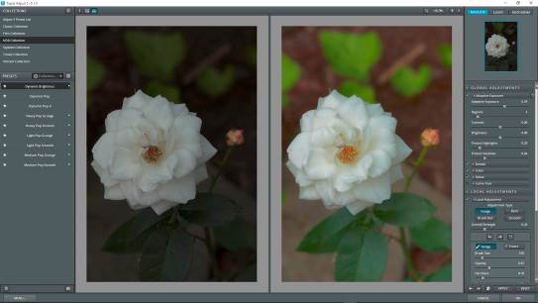

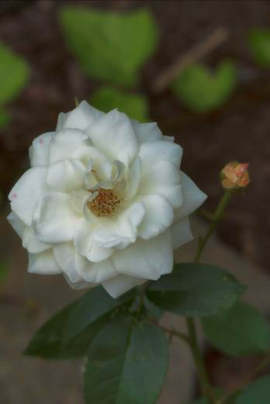
The image above shows a Before / After view of the image in the main workspace. To activate this, there is a button to the top left of the preview window. Click it to open this view; the icon to its left will return you to the After-only view. If you’re wondering, I chose the Dynamic Brightness preset from the HDR preset collection for this image.

Once you have tweaked any settings you wish, you can apply them to the image and return to your image editing program for further operations. The plug-in will close, and the changes made will be applied to the image, allowing even more editing to be made with other tools.

Topaz Adjust gives you a lot of control over how your photo looks. Details such as contrast, brightness color and noise can all be handled via these sliders. You will also find that you can make changes to your image Globally, Locally (targeted to specific areas), and add Finishing touches to further refine how it looks.

At the bottom left of the main screen you will find a Menu button. Clicking this takes you to some functions to adjust how the plug-in operates via the Preferences option. Here is where you also enter your License key after installation. There is also a link to the online User’s Guide, which can help you with any questions you may have concerning specific functions or operations of the plug-in.

B&W Effects

As the name implies, this is the plug-in you would choose if you do black and white photography, or need to convert color images to monochrome.

While Photoshop allows you to convert color photos into B&W with a built-in tool, it sometimes is not the best choice. Colors can translate into grayscale tones in unpredictable ways, leaving you with more work to do afterwards.

Using Topaz B&W Effects, however, gives you more control over the results. The interface is similar to that of Adjust, but populated with tools more suited to working with black and white images.

You will also find the usual libraries of Presets on the left panel, and the preview window in the center. The tools and adjustment sliders are on the right panel.

To the left is the original I chose to convert to a monochrome image. As you can see, it was shot on a bright sunny day, which is sometimes a harsh light to be shooting in.

After opening the original in Photoshop, I brought it into B&W Effects via the Filter menu. Once there, I was presented with the image in the Topaz interface:

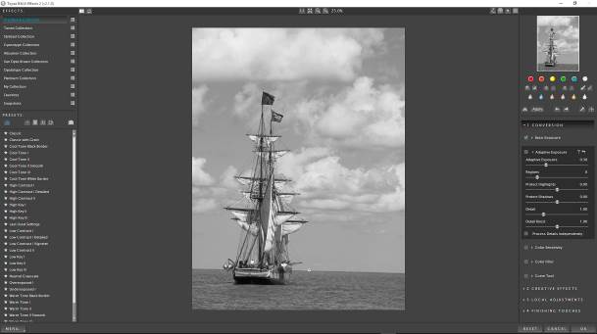
As shown in the preview window, the image is now in black and white, at a default starting point. From there, I ran through the presets, selecting one from the Traditional collection that had a bit more contrast to it than what the default gave. I added a red filter in the tools panel, increased the contrast by 2 more click, applied a film grain of Kodak Tmax Pro 3200, and gave it a Grunge White 5 border effect.

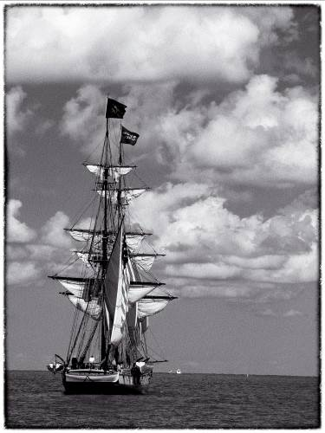
The finished image is seen to the right

Reproduction of some photo types and styles in print format is sometimes difficult. Seeing the final results printed out as an actual photo gives you more of an understanding of what you can achieve with these tools. Such is the case with the black and white images shown here. Also, space limitations makes it hard to give a truly complete overview of all the products that make up this bundle. But why not download the free trial and try it out with your images? That will give you a better view of what is going on.

For those of you familiar with b&w photography, the filters you could use on your lenses, the dodging and burning of the print in the darkroom… all those techniques and more have been reproduced here for you. What you could do by physical means at any point during the image creation process has been included, allowing you to work with those effects digitally, recreating them in one software program, rather than several different points. Not only do you have more control over the results, you can tweak things to any degree and come up with an image you may not have been able to produce using film and a chemical darkroom.

Black and white imagery is not dead…it’s alive and well, and being used by many photographers as a way to make an even more powerful image than what a color print can give.

Topaz Clarity

So you’re out on a shoot, taking photos of the local sunset at the shore. The colors are bold and brilliant, deeply saturated, and the contrast and exposure are what true works of art reflect. You fill up your memory cards, and head home to download them onto your computer and review the results.

What you see on the monitor makes your heart sink… flat, low contrast images, some of them underexposed and dark…nothing like what you had seen on location. Such an example is this image I shot.

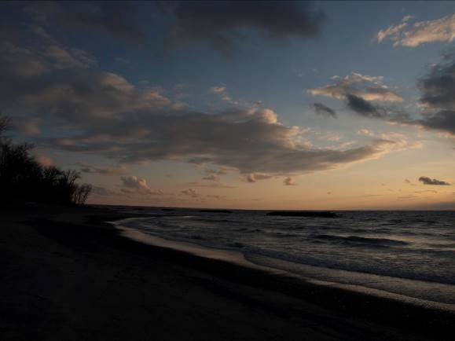

The camera settings were not off as far as I can recall. It’s just another case of the camera not being able to see everything our eyes can. It did what I told it to do, and it reproduced the image as best it could…but it’s not what I was aiming for.

Topaz Clarity to the rescue! This plug-in analyses your image and makes adjustments to the contrast, white and black points as well as mid-tones, and also what Topaz calls micro-contrast - a finer control of contrast in the image than the normal adjustments can make.

As with the other products, the interface is similar, and there is a library of presets built-in, giving you a starting point.

For my image, I selected one of the Landscape presets to use as a starting point, then made further adjustments from there. I adjusted the micro-contrast as well as the low, medium and high contrast sliders, and bumped the black and white points under Tone a bit.

The nice thing about Topaz Clarity is that it enhances your images without making any halos or other artifacts present in the final image. Some tools or other filters may do so to some extent, but pushing the adjustments in Clarity did not introduce anything noticeable, even when magnified.

If you’re a Lightroom users, you know that there is a clarity adjustment slider built in to the program. It does basically the same as the Topaz plug-in does, but it’s somewhat limited in its operation. With this plug-in, you have a wider range of control over how the effect is applied… even to the point of being able to apply masks for selective effects.

After applying my adjustments, the final result revealed the following image:

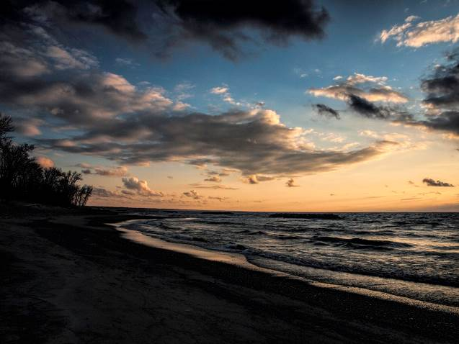
Compared to the before, the final output is crisp and clear, with much higher contrast, and more saturated colors and finer details. It resembles the original scene much more closely, and is what the final output should be.

If you’ve wondered how clarity works, it emphasizes the difference in light and dark edges of objects in your image. In my sample image, it enhances the change between the edges of the clouds and the sky, making it sharper and more defined. The clarity control in Lightroom affects all areas equally. In Topaz Clarity, you can adjust areas of low, medium and high contrast separately, and even mask areas for finer control. Plus you have a micro-contrast control, which allows you to adjust the contrast differences in areas where there are very small changes to further enhance fine detail. Combine this set of adjustments with the others found in this pug-in, and you have more control over your image quality than you can achieve easily in other applications.

Topaz Clean

With Topaz Clarity, the plug-in worked on the contrast between edges of objects in your image. With Topaz Clean, it targets the surfaces of objects, allowing you to perform such tasks as smoothing skin, smoothing imperfections on chrome surfaces, reduce blemishes and surface textures on flowers, and many more.

This plug-in would be ideal if you are a portrait photographer, and want a fast and easy way to smooth out the skin of your subject. However, this is a global adjustment plug-in, so you may need to do some masking afterwards to ‘turn off’ the effect in areas that don’t need smoothing. Unlike some of the other plug-Ins, this one does not have masking abilities built-in, so your image editor would come into play once you have the effect you need.
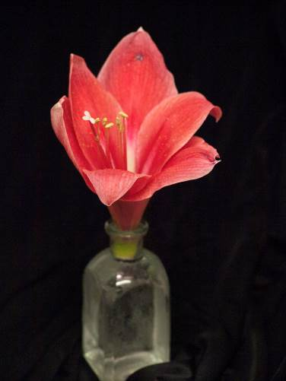
I have very few portraits in my archives, as I do not shoot them. I mainly concentrate on nature and landscape subjects, so I found the image to the left to illustrate the effect of Clean on the image quality.

This is the original image. Notice the texture of the flower petals, which appear somewhat rough and grainy looking. Sometimes skin has this look due to lighting effects or just the normal appearance of the subject’s skin, so I thought that this would work for a sample image. I loaded it into Photoshop, then opened it in Topaz Clean.

Once in the plug-in, rather than starting with one of the presets available, I decided to try out the ‘pot luck’ feature. Down at the lower right of the workspace, next to the Reset button, is an icon labeled I Feel Lucky in the user guide. It applies random settings to your image, giving you another starting point to work from (of the plug-ins reviewed this month, the only other one with this feature is Adjust).

I stepped through a few of the randomly generated setting results, until I hit on the one I chose to use.

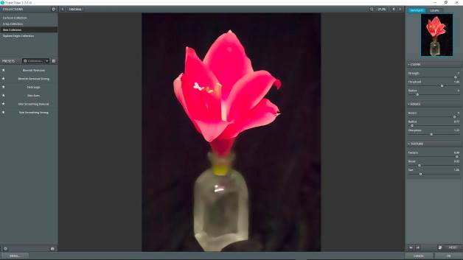

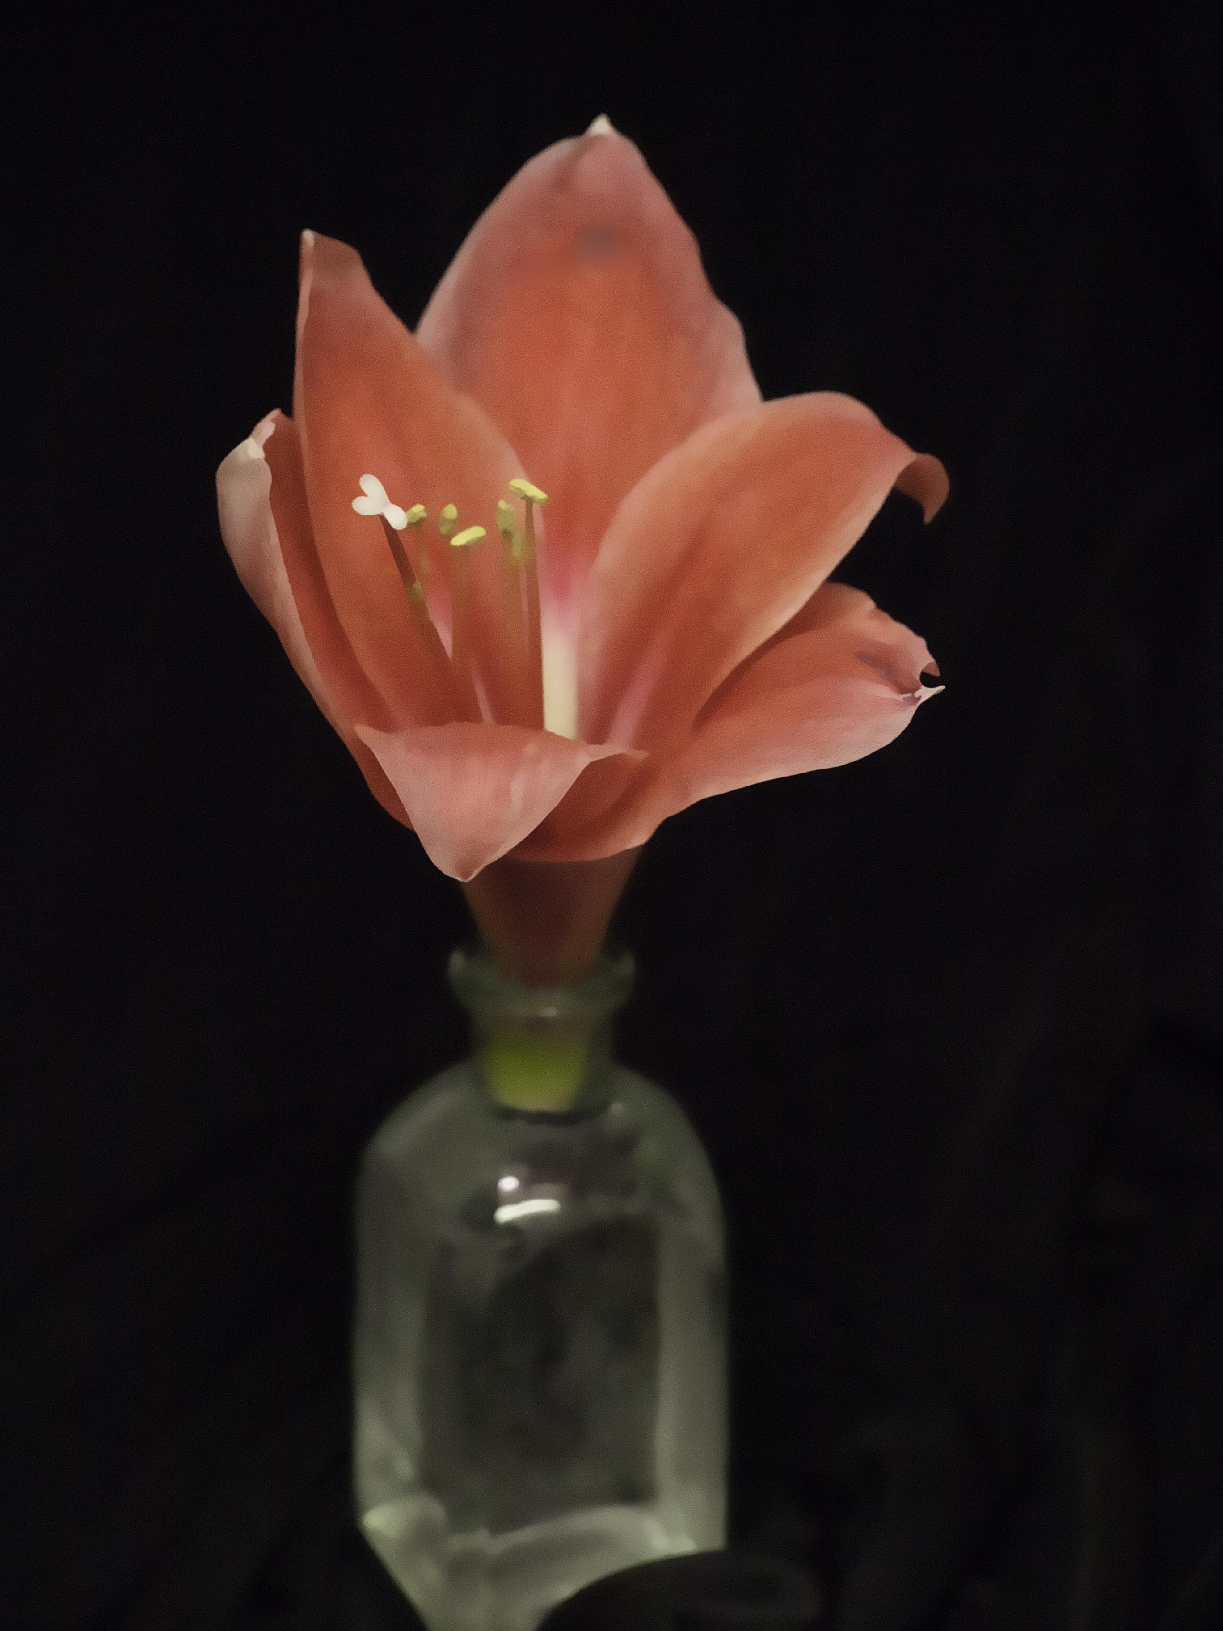
Once back in Lightroom (after applying the settings and saving the file), all I really had to do was tweak the clarity a bit, bump up the saturation a few clicks, and adjust the sharpening, to reach the final image.

I used Lightroom’s Clarity adjustment mainly because I didn’t want to undo the smoothing of the petals Clean had accomplished. I tried Topaz Clarity first, but it did too good of a job, and started bringing out the texture as found in the original image.

The final image shows nice smooth petals, with a somewhat creamy appearance to the colors. It’s a lot more appealing than the original, in my opinion.

That wraps up part 1 of the Topaz Photography Collection review. Next month we’ll take a look at DeJPEG, DeNoise, Detail and Glow. Until then, don’t forget about the 15% discount available until September 30th.

