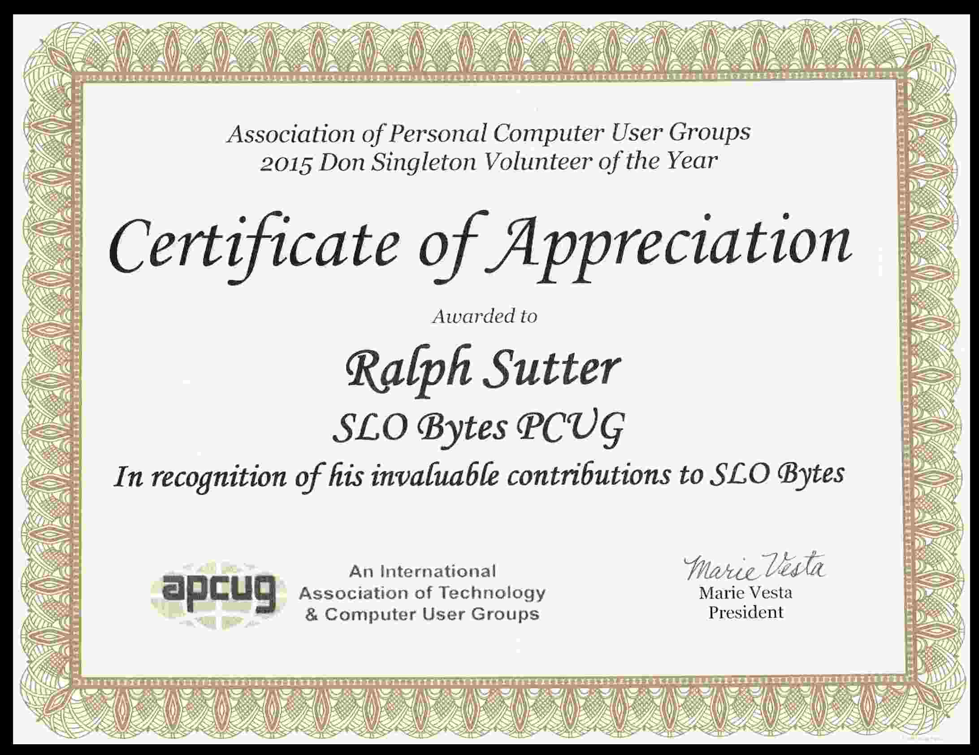

The above Certificate of Appreciation was presented to SLO Bytes Volunteer Ralph Sutter on February 7, 2016 by Alan Raul on behalf of APCUG, the Association of Personal Computer User Groups.

An International
Association of Technology
& Computer User Groups
Ralph Sutter, Secretary/Webmaster/Newsletter Editor/
Digital Photo Group Leader
SLO Bytes PC Users Group
Nomination Information
By Alan J. Raul
1 . Brief explanation of why you feel your user group's nominee should receive the Don Singleton Volunteer of the Year award.
Ralph has gone far above what not just one person would do but 3 or 4 people would do. Without Ralph volunteering for a variety of different roles in club, the SLO Bytes PC Users Group would not be the PC club that it is today. It might not even exist!!!
- Describe how your volunteer has made a difference to your user group.
Ralph has kept an old PC Users Group current in a dwindling environment where other computer users groups have faded away. Volunteer efforts never seem to be recognized by others. Ralph could be doing anything he wants but chooses to spend his time and talents with the SLO Bytes PC Users Group. Ralph spends countless hours each week for the group.
- Show specific examples of your volunteer's roles and responsibilities.
Secretary - Ralph takes the monthly minutes of the Board of Directors meeting and posts them online.

http://slobytes.orq/minutes/indexhtml
Webmaster - Ralph maintains the clubs web site CONSTANTLY with updated information. Ralph also maintains the SLO Bytes Bulletin Board.
http://slobytes.org/
http://www.slobytesx)rg/smf/
Newsletter Editor - Ralph gathers all the information about the past presenter and the upcoming presenter in addition to club news and e-mails the membership and posts the information online. http://slobytes.org/news.htmi

Digital Photography Group leader - Ralph hosts this monthly SIG at his house providing not only great photo topics and discussions but a variety of healthy snacks and gourmet coffee.

http://www slobytes.org/digitaí/
4. Explain how your volunteer has shown initiative and leadership in his or her efforts.
When a speaker/presenter cannot be found Ralph will step up and locate a speaker or do the presentation himself.
Ralph took over duties that no one volunteered for without anyone asking him to do the job.
Ralph will also fill-in at the Linux Users Group when the Coordinator is not available.

