Davinci Resolve Notes
YouTube link to my Water video https://youtu.be/VwFPxCW8G1o
To see past Projects, click on File/Project Manager
To Close a Project, Click on File/Project Manager/Close (name of Project to close)
To delete a Project. First close the Project if opened then File/Project Manager/Right Click on name of Project to delete/Delete
To change the size of the Timeline, hold down the ALT key and move the Mouse Scroll Wheel
To delete gaps, make sure that you have the cursor on the timeline and then click on Edit/Delete Gaps
To Hide Tabs (called Pages in Resolve) at the bottom of the screen click on Workspace/Show Page/Uncheck Tabs to Hide
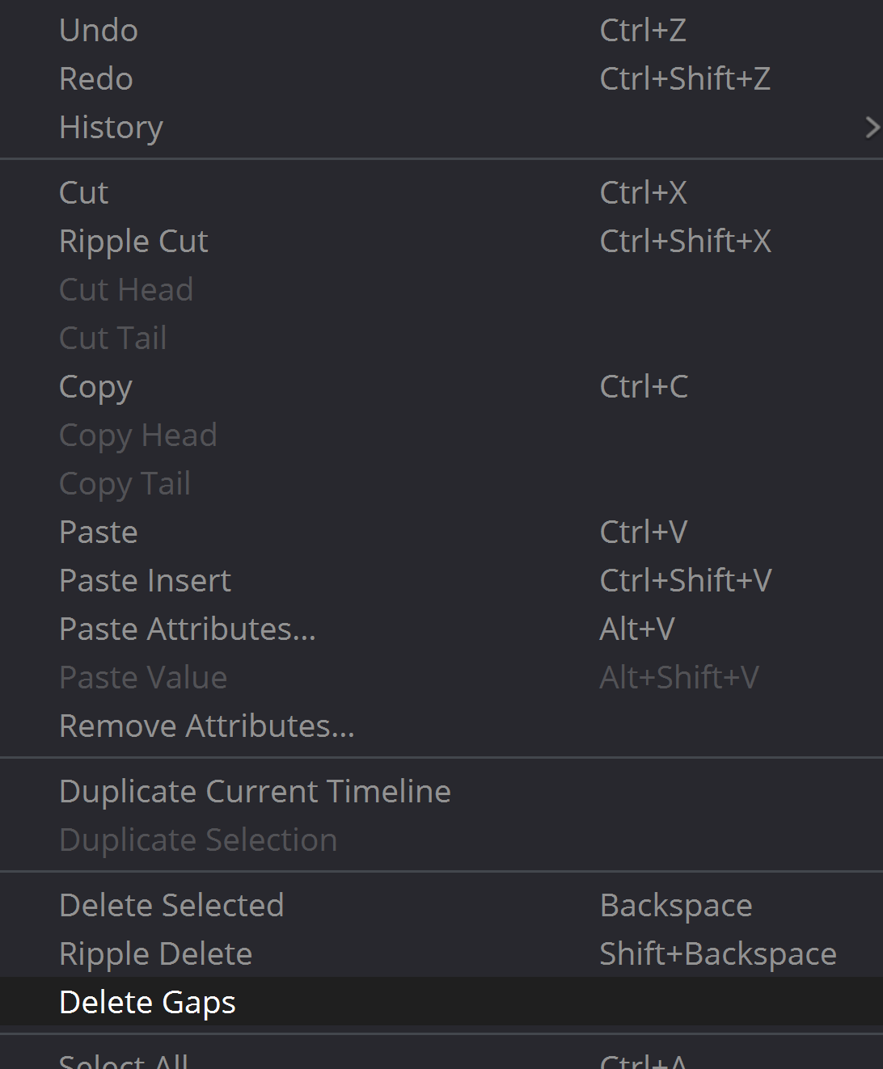
To hide the Media window, click on it and it will close
To change the displayed Monitor screens back and forth between one and two screens, click where the arrow points
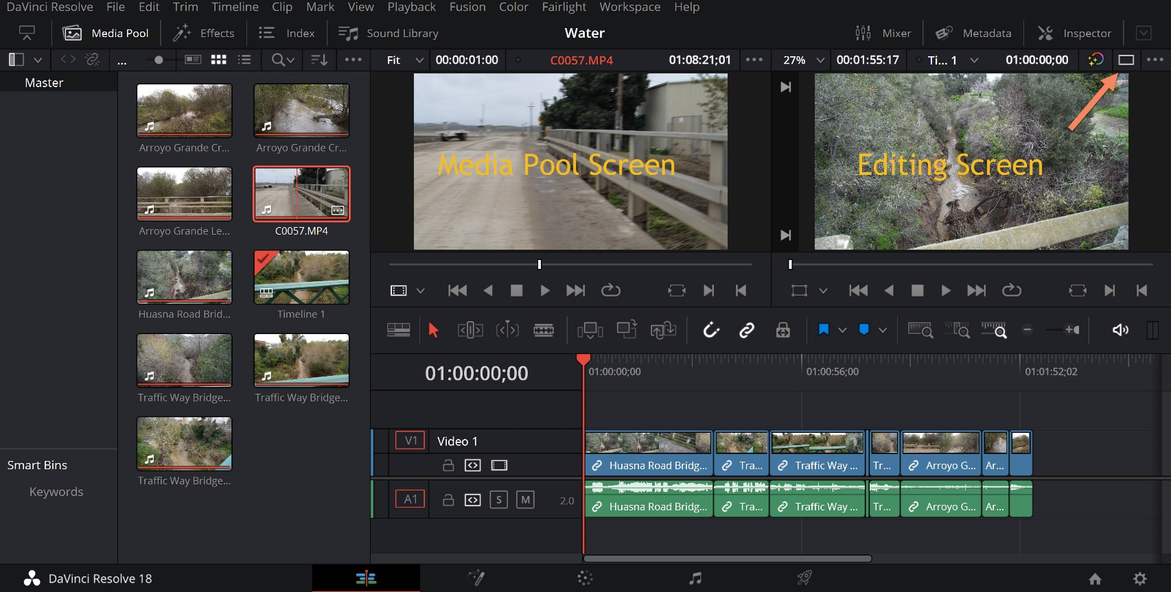

To view Sound Effects, go to the Sound Library and type *** to the left of the Filter By Window 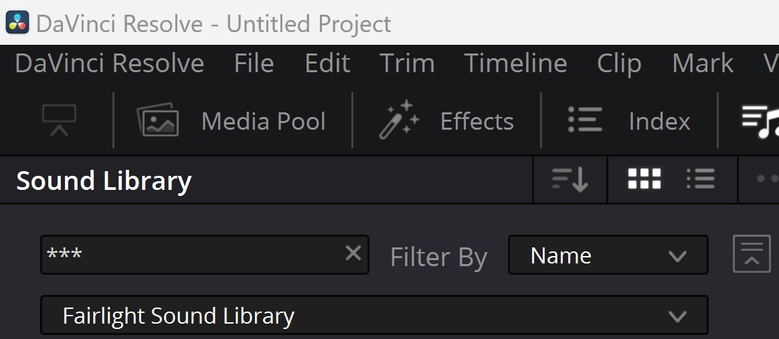
To insert sound effect, create an empty audio track, open Sound Effects tab and drag sound effect onto new audio track timeline. NOTE: It is sometimes necessary to drag it twice before it works
To Unlink (separate) video and audio tracks, place the selection arrow on the timeline at the desired point, hold down the Alt key and click
To set where Media is saved, click on File/Media Management and browse to desired location
To display the Monitor Preview in Full Screen hold down the CTRL key and press F
For Slow Playback (aka Play Slow) press Shift K
Audio Notes
Set Audio Preferences in Davinci/Preferences
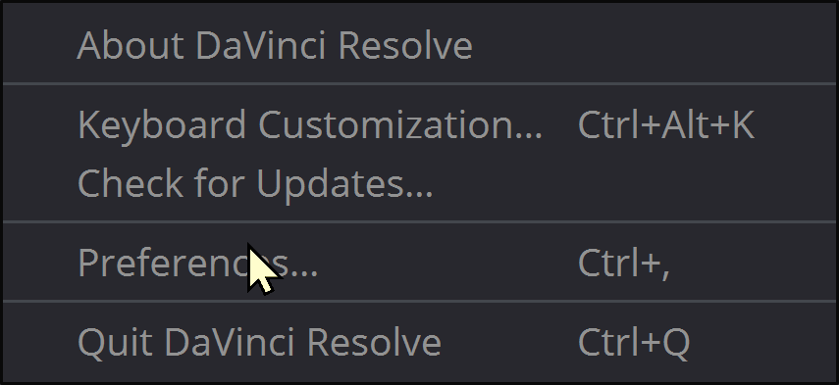
The (Yeti) microphone has to be turned on before it is offered and an Input option
The microphone must be Patched before new audio can be added to any sound track
The red light on the Yeti microphone can’t be flashing. It must be solid red to use the mike

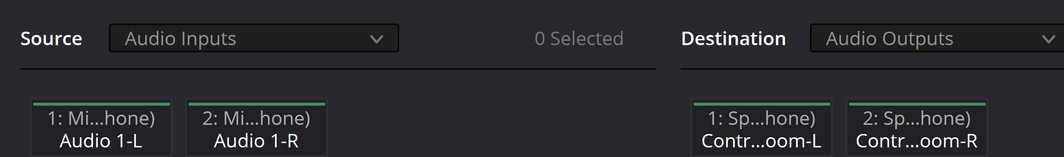

If no Audio is heard, check the Davinci Preferences to see if the wanted Input and Output Devices are chosen
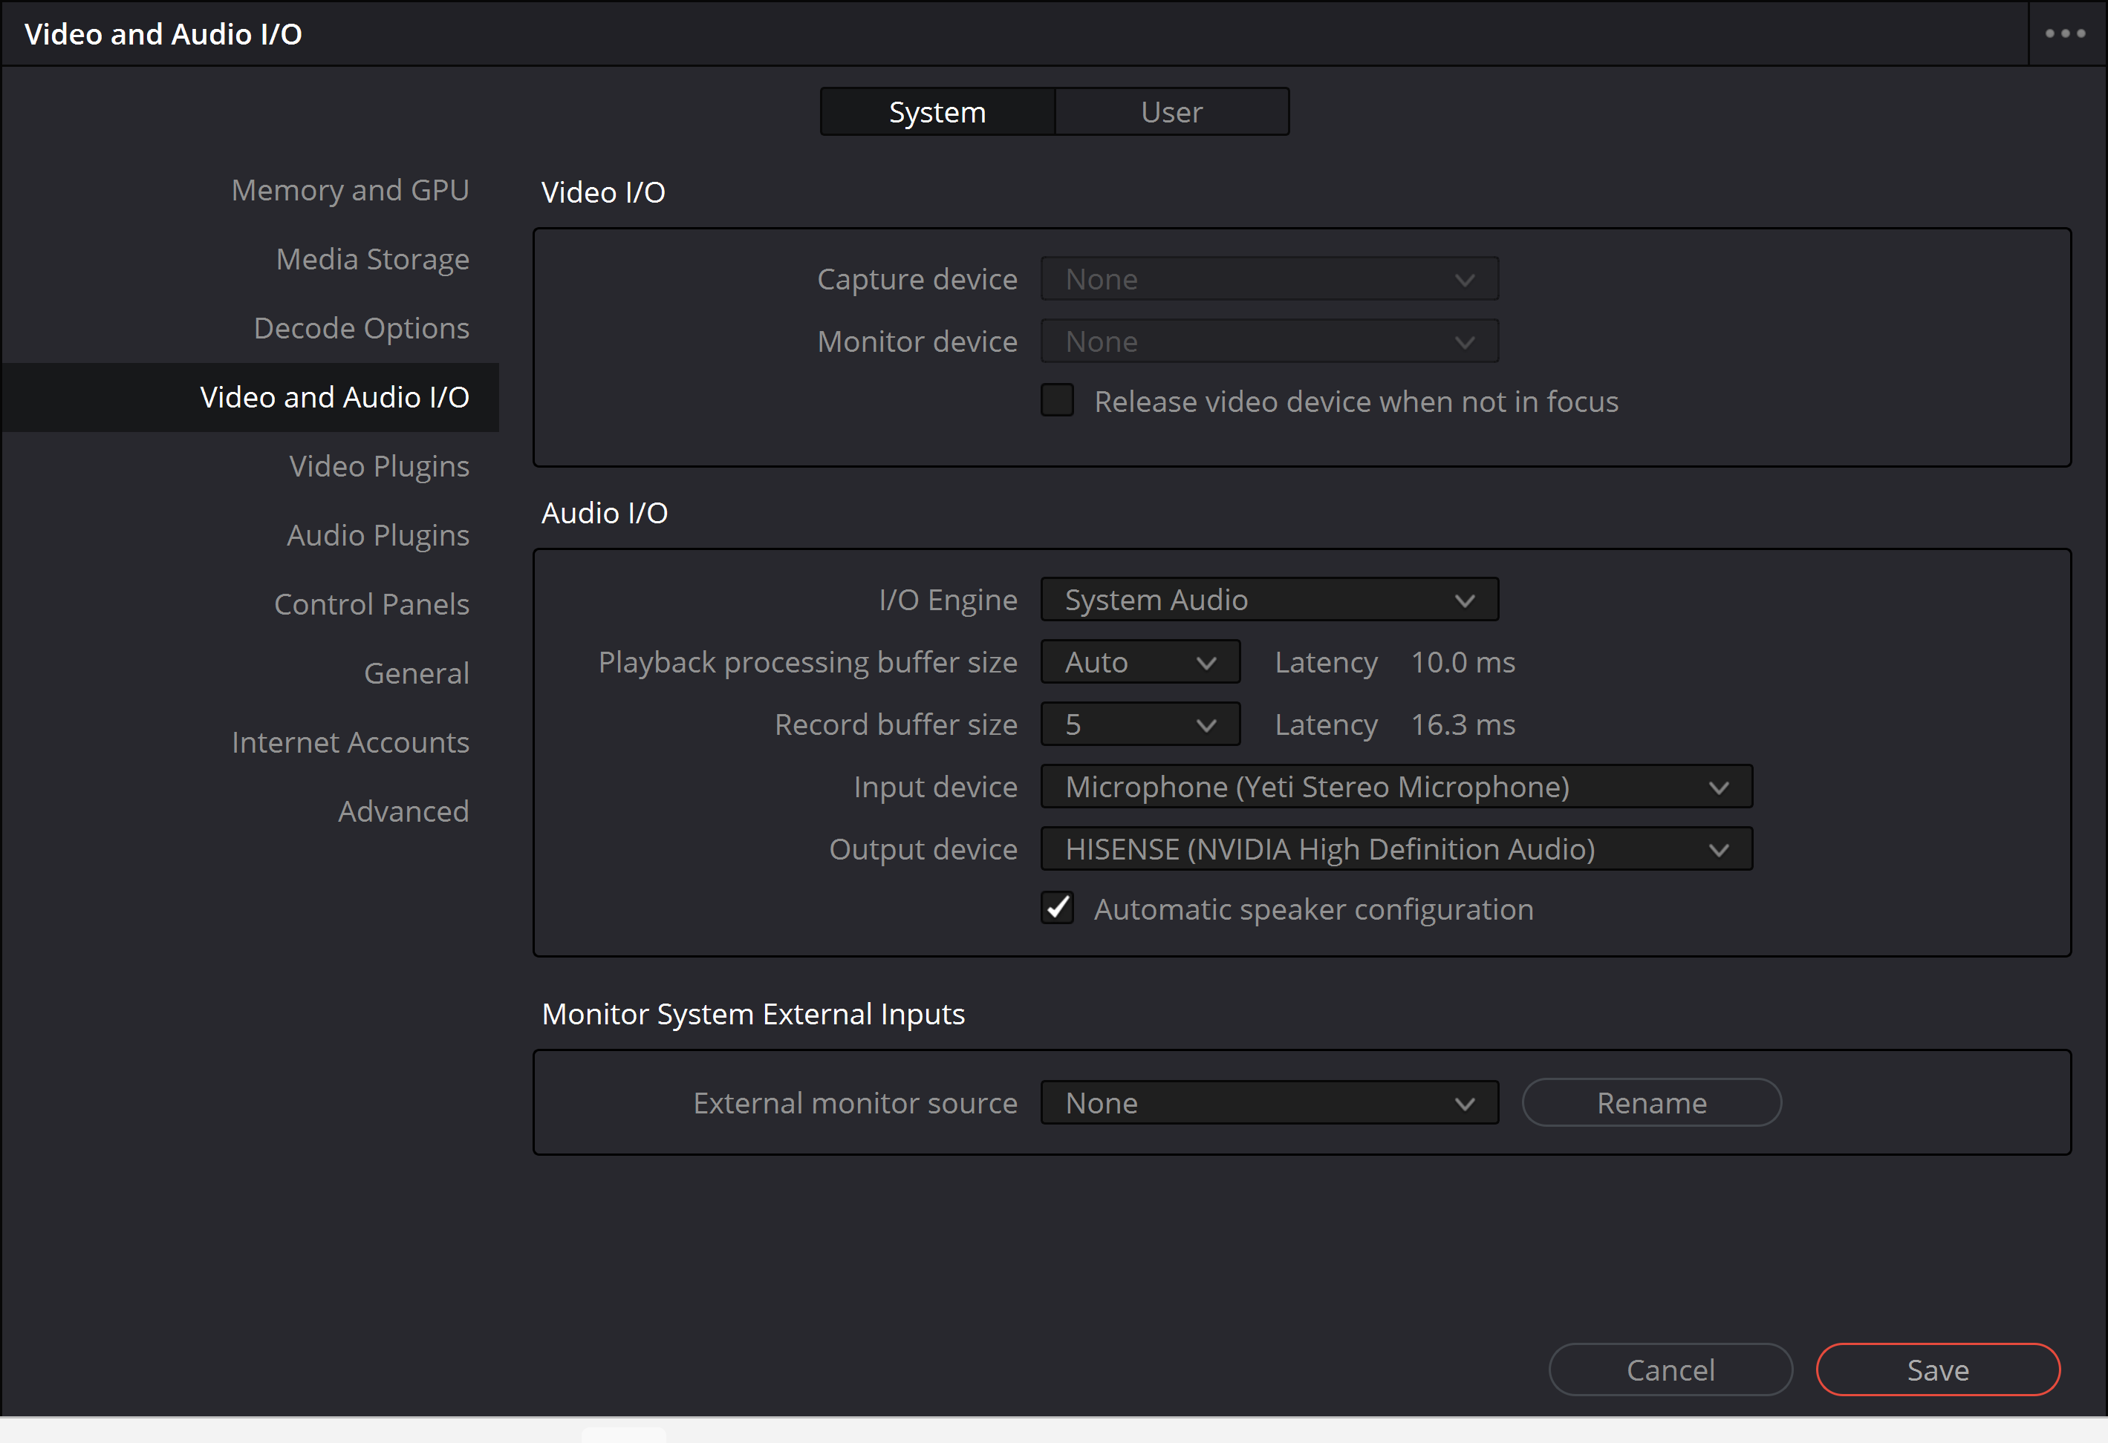
To grab a still from a video do this
Open the Color tab at the bottom of screen
Also open the Gallery tab at the top of the screen
Right click on the Timeline at the time when you want to grab the image
Click on Grab Still
Whatever you grabbed will automatically appear in the Gallery Tab
Click on the grabbed image and export it to the desired folder, first changing the format to .jpg or whatever format you prefer

Space here for expansion above
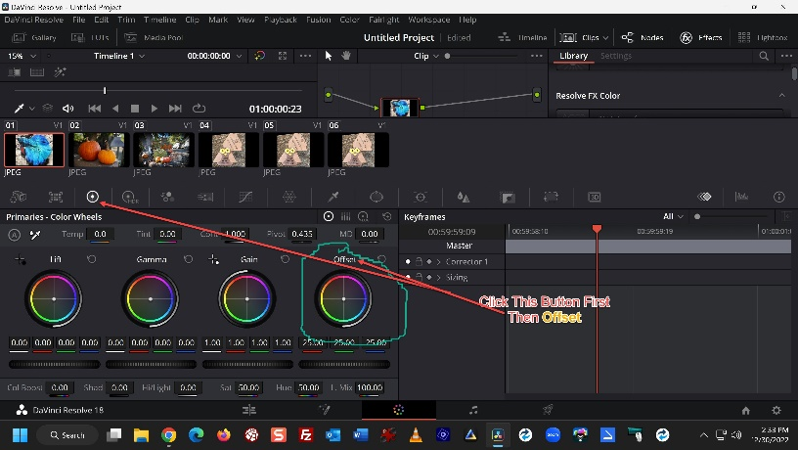
To brighten Color, go to COLOR, click on the third circle, click on OFFSET

YouTube Links for Davinci Resolve
Download Davinci Resolve 18 Scroll down to the Download section and choose the platform; Windows, Mac or Linux
Davinci Resolve 18 Full Tutorial for Beginners I recommend that you start here
Davinci Resolve File Locations
Upload Directly to YouTube from Davinci Resolve 18
Add an Audio Track to Davinci Resolve
If I can’t rename an Audio Track, as seen in the image above, just increase the height of the Audio track and a name will appear. Right click that name to rename
Reset Davinci Resolve https://youtu.be/uln3lrT-B9k

How to add Zoom Effect to Davinci Resolve
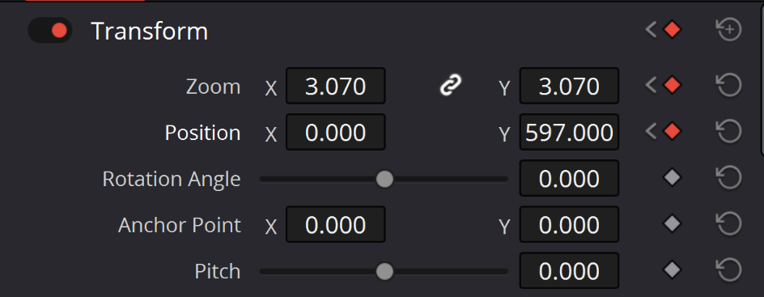
Note to Self: The proper sequence is Position Play Head/Open Inspector/Click on the Video and Audio Diamonds
Then click on the Toggle Keyframe Diamond
Move the Play Head to the point where the zoom will end
Next hold down the left mouse button and move mouse left or right to change values

To show Markers, go to the Edit tab, click on Index and open the Markers tab

