Serendipitous Symmetry

1 Japanese Flower: Phi at its finest!
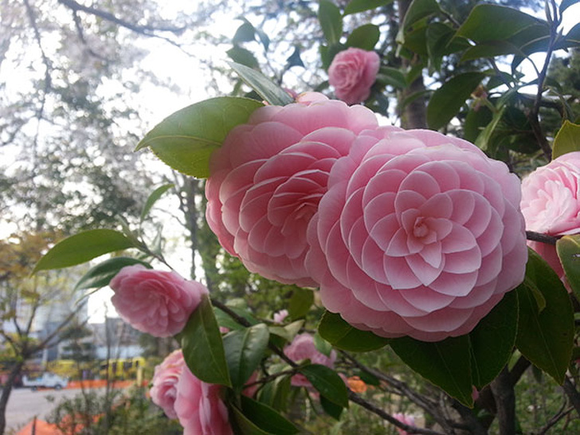
2 The pattern created by the snow on this bench
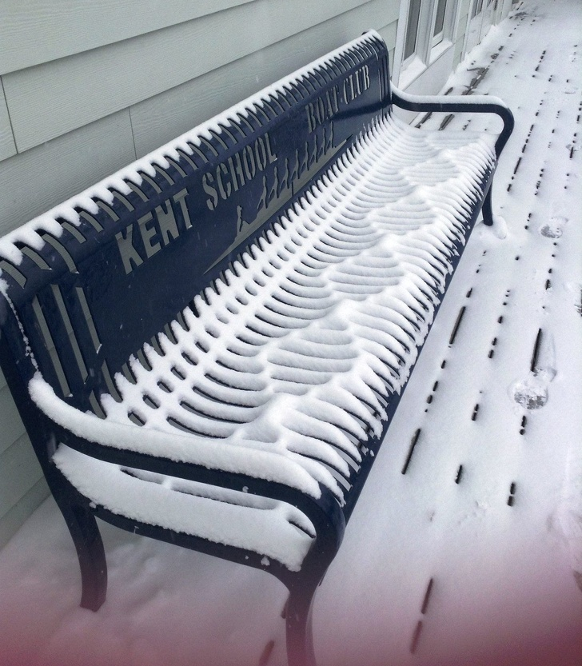

3 The way these tennis rackets are arranged
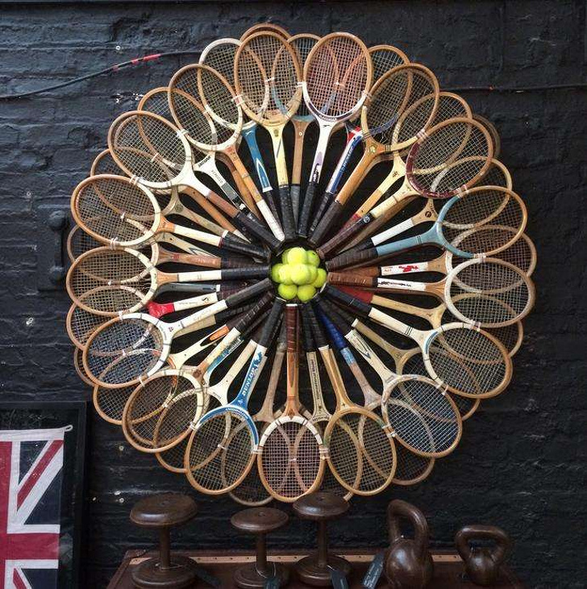

4 The first level of bubbles
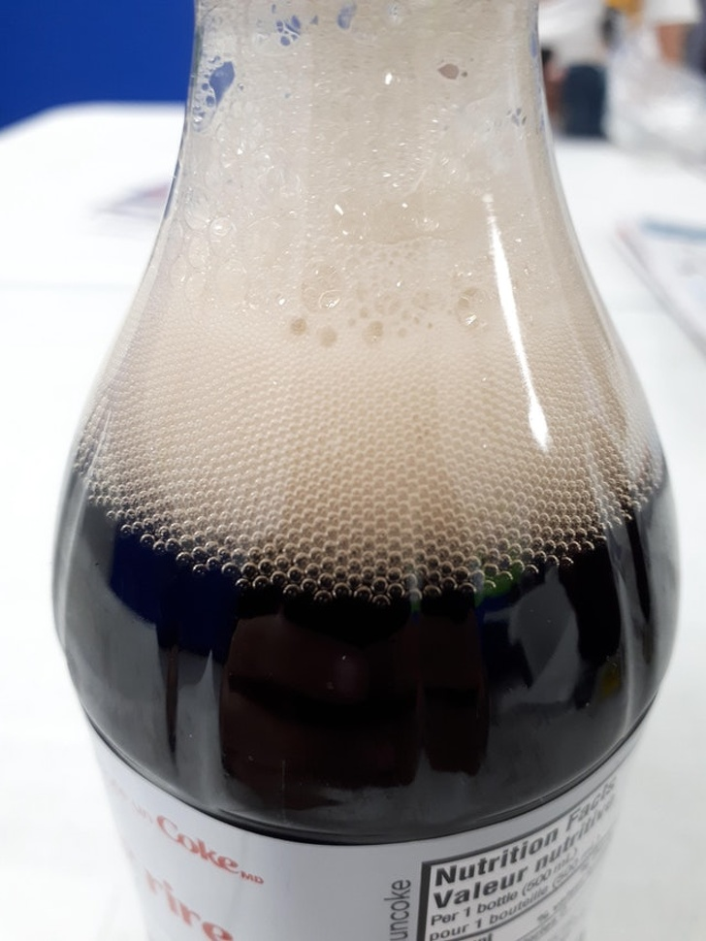
5 Can't eat it, it's too perfect!
6 The perfection in this handwriting
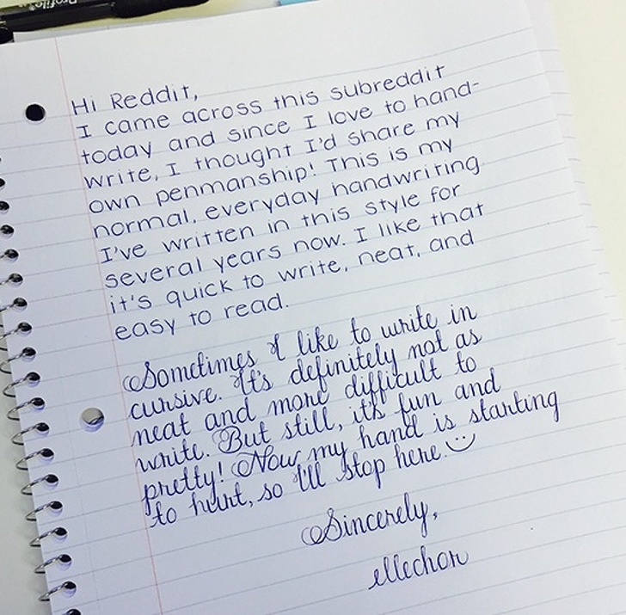
I think her cursive writing is extremely
easy to read. It takes a long time to
write like this, which is why most people
opt for scribbling.

7 These piles of spices at
a market in Marrakesh
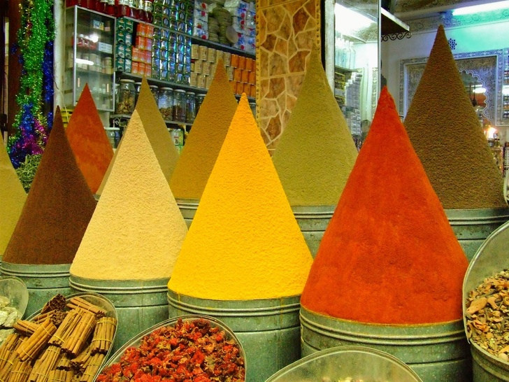
8 This bundle of pencils at a library
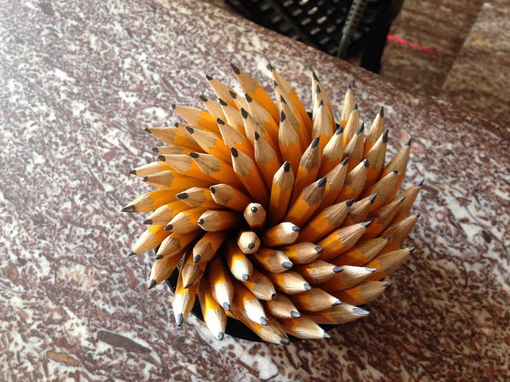
9 The perfection of this table
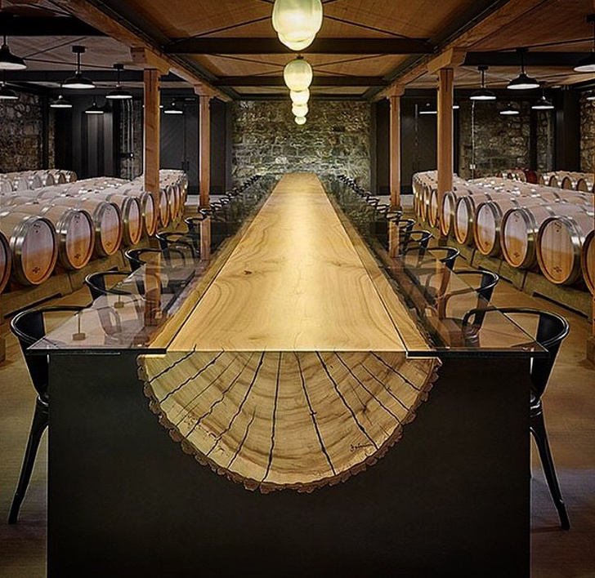
10. A living tomato ripeness chart
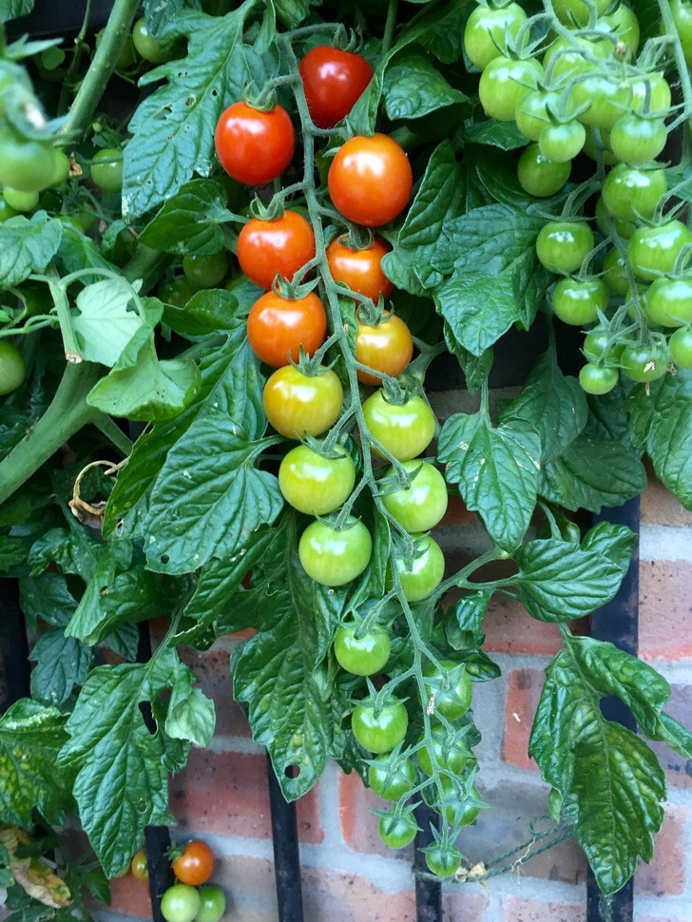
11. This glass holds exactly one can
of soda right to the brim.
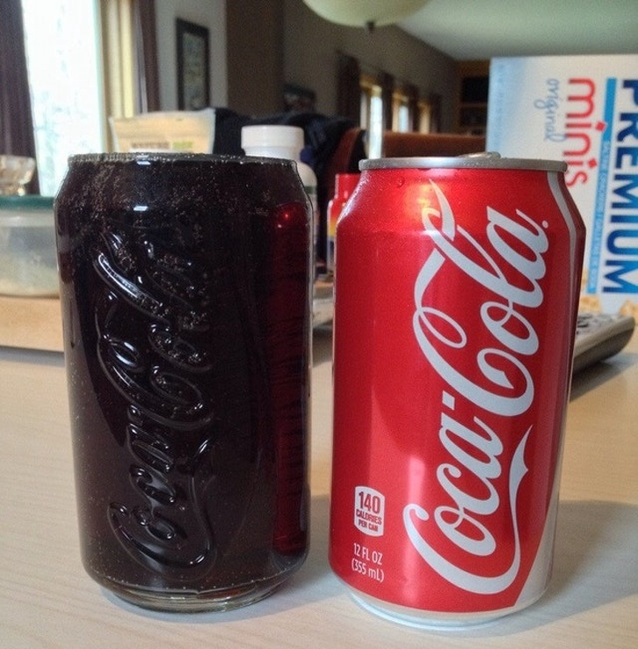
12. The symmetry of this interchange
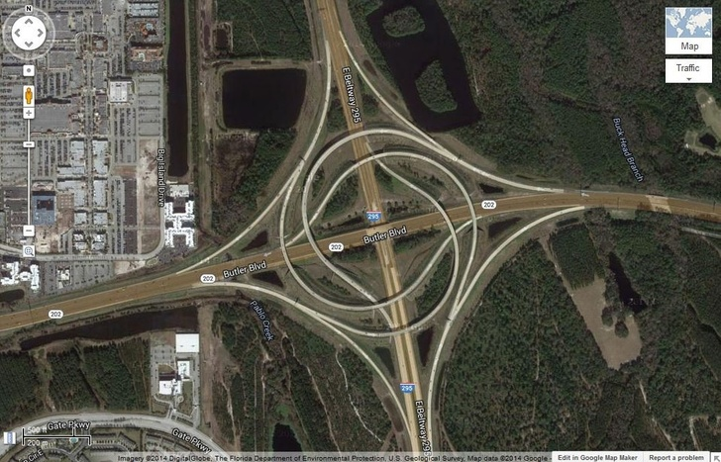

13. "We found our guidebook cover
on the Appalachian Trail."
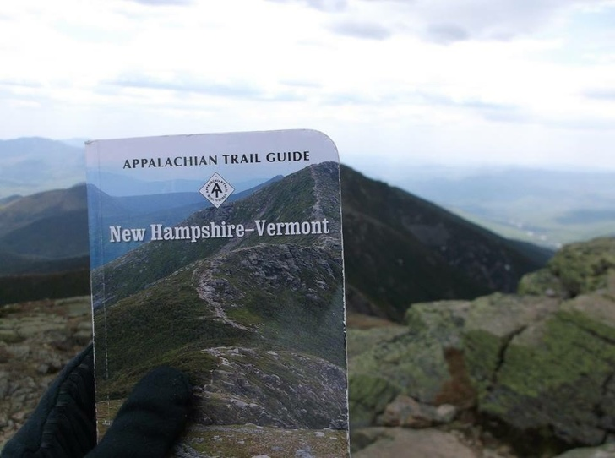
14. The way this field is cut
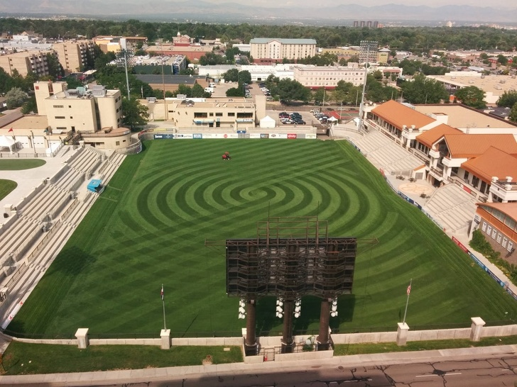
15. The arrangement of these tomatoes
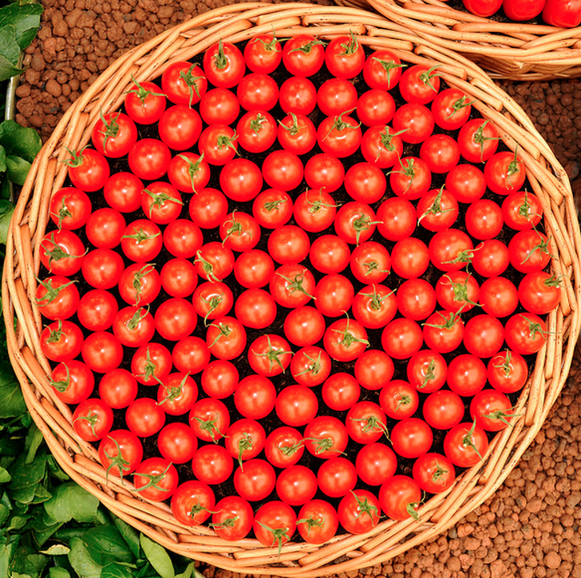
16. The way this snow is folding
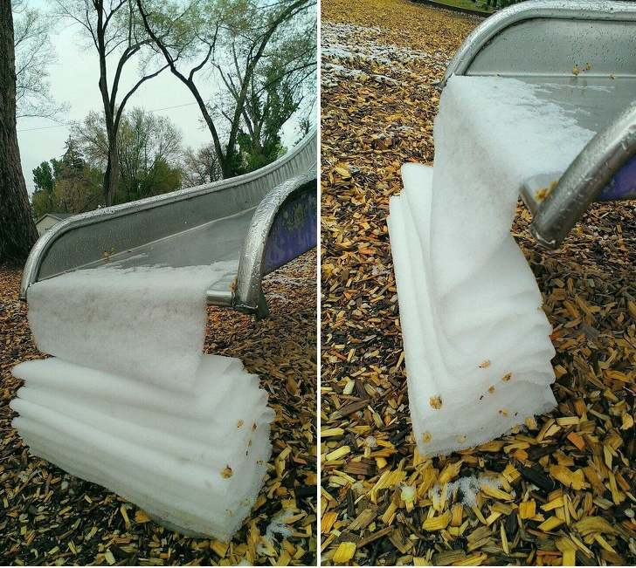
Have you ever seen snow fold?
That's stunning!
17. Please, don't let it melt!
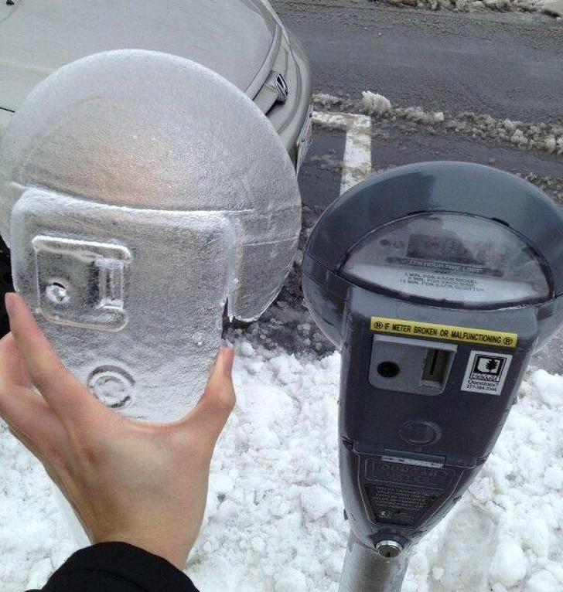
18. Accidentally perfect
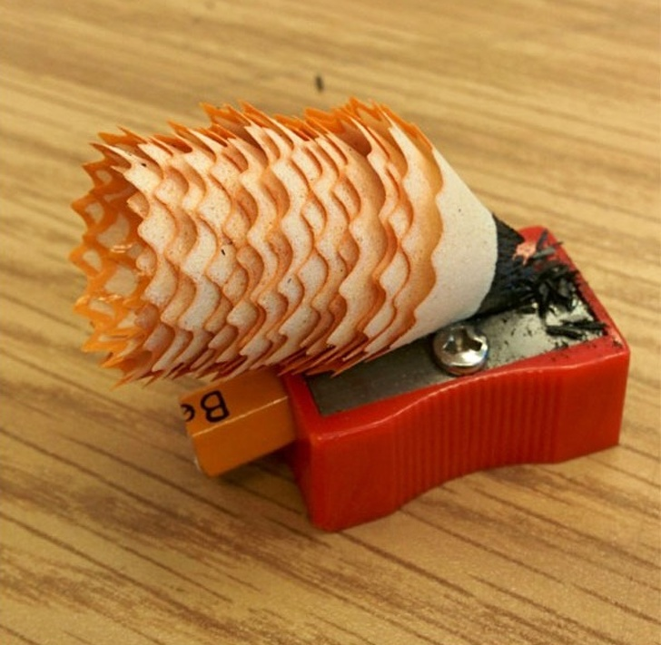

19. "I walked into the room and
realized the floor had chosen
the same outfit as me."
20. This whole veggie display
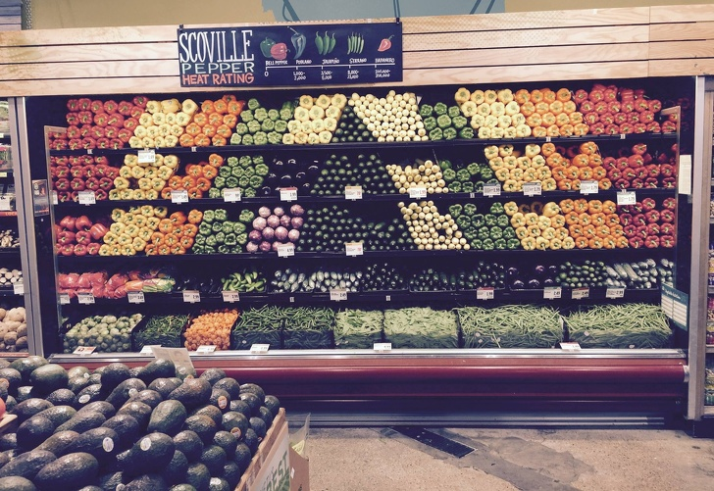

21. This is not a collage,
it's just a single photo.
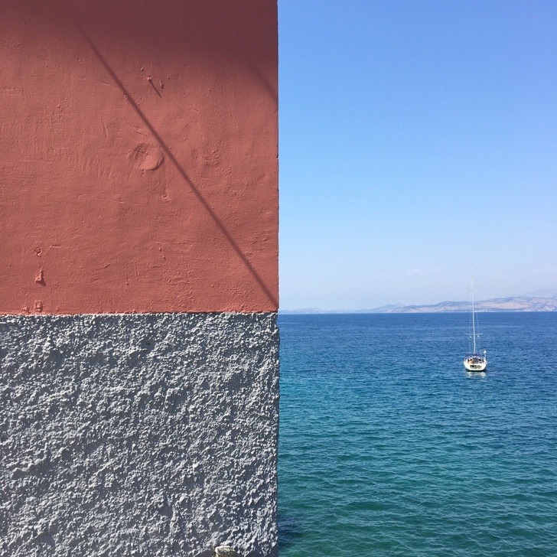
That's so unbelievable.

The wall is half of the picture,
and the two colors meet at the horizon.

22. Amazing natural geometry in cabbage
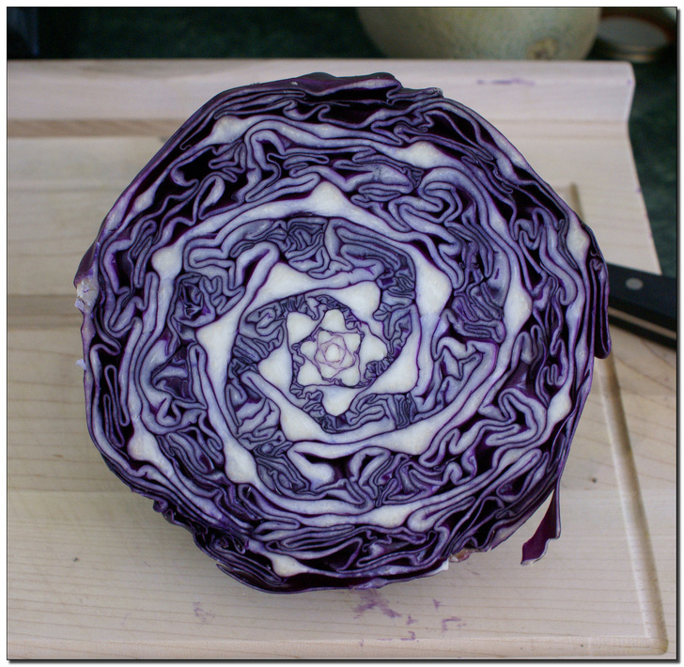
Now this is a work of art!

23. The mountains and trees lined up
perfectly on this camper on the highway.
24. These wine glasses
