**Upgrade to Windows 11?**

If your members are planning to update to Windows 11, they will need to check to see if their computer is Win 11 compatible: Settings>Update & Security. If they see the below information, they are good to go. My 5-month-old HP is ready. One of Bill James' Windows 10 computers received the other notification yesterday; he is already using Win 11 on his Windows Insider computer and one has the -- is ready notification.

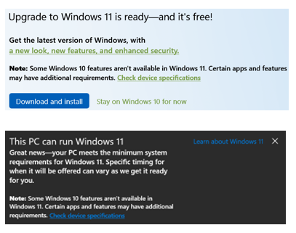

If not, they might need to buy a new computer; many of the big box stores are already having Black Friday sales.

Their computer also needs to be Secure Boot capable. See the below Secure Boot link. From the below article: "*While the requirement to upgrade a Windows 10 device to Windows 11 is only that the PC be Secure Boot capable by having UEFI/BIOS enabled, you may also consider enabling or turning Secure Boot on for better security."*

[Windows 11 and Secure Boot (microsoft.com)](https://support.microsoft.com/en-us/windows/windows-11-and-secure-boot-a8ff1202-c0d9-42f5-940f-843abef64fad)

If it is Secure Boot capable, they need to see if the required TPM feature is turned on. If it is not, they should turn it on and click on Check for Updates with fingers crossed. See the below TPM link.

[How to check if your PC has a trusted platform module (TPM) | Windows Central](https://www.windowscentral.com/how-check-if-your-pc-has-trusted-platform-module-tpm#:~:text=Confirm%20TPM%202.0%20with%20Settings.%201%20Open%20Settings.,to%20confirm%20the%20chip%20is%20version%202.%20)

How about going through both steps at an upcoming meeting? Or a presentation with step-by-step instruction screenshots to make it easier for members to check their computer's status.

**=================================**

Don Arrowsmith, President, Philadelphia Area Computer Society doesn’t usually point out shopping deals, but HP is selling Microsoft 365 Personal 1-year subscriptions at 25% off ($52.49 vs. $69.99 list) for a limited time. (Microsoft 365 Family is $10 off its $99.99 list.) These are seldom on sale. If you already have a subscription, you can add on another year with this item. See the HP shop for details.

[Microsoft 365 Personal 12-Month (DLM3PZG3QWK3PLB) (hp.com)](https://www.hp.com/us-en/shop/pdp/microsoft-office-365-personal-32-64-bit---subscription-license---1-pc-mac--1-phone--1-tablet---1-year)

(Amazon / $58.99 auto renew @ $69.99/year); not for extending your subscription. JT)

**What Microsoft Office suite are they using?**

Windows 11 will continue to support 32-bit apps. But 64-bit is faster and more secure.

[64-Bit & 32-Bit: What Do They Mean? (lifewire.com)](https://www.lifewire.com/32-bit-64-bit-2624554)

[Does Windows 11 Support 32-Bit Applications? (intowindows.com)](https://www.intowindows.com/does-windows-11-support-32-bit-applications/)

[How to Find Out Which Version of Microsoft Office You’re Using (and Whether it’s 32-bit or 64-bit) (howtogeek.com)](https://www.howtogeek.com/288001/how-to-find-out-which-version-of-microsoft-office-youre-using/)

[Choose between the 64-bit or 32-bit version of Office (microsoft.com)](https://support.microsoft.com/en-us/office/choose-between-the-64-bit-or-32-bit-version-of-office-2dee7807-8f95-4d0c-b5fe-6c6f49b8d261#32or64Bit=Office_2013)

[Microsoft Office 2021: When Is It Launching and How Much Will It Cost? (makeuseof.com)](https://www.makeuseof.com/microsoft-office-2021-when-launching-how-much-cost/) - $124.00 @ Amazon, regularly $149.99.