SLO Bytes HardCopy
A publication of the San Luis Obispo PC Users’ Group
Vol. 37 No. 9 September 2021
August 1st 2021 First Session Notes by Alan Raul
Dell XPS 8940 Desktop - Dual Boot Ubuntu Mate Linux and Windows 10
http://www.slolug.com/dell/
Flaws in Dell's over-the-air device recovery and update impacts millions of devices
https://www.csoonline.com/article/3622968/flaws-in-dells-over-the-air-device-recovery-and-update-impacts-millions-of-devices.html
https://news.softpedia.com/news/30-million-dell-devices-vulnerable-to-remote-bios-attacks-533337.shtml https://www.theregister.com/2021/06/25/dell_supportassist_biosconnect_vulns_rce/
Netflix-Codes.com - You probably know that Netflix is using a strange system to categorize it films and tv shows. Indeed, there isn't any categories tab... We have the solution, with this site, you will be able to find categories by a little code.
http://netflix-codes.com/
Windows 11 with Microsoft Office
https://office-watch.com/tag/windows-11/

Fix Windows Update errors by using the DISM or System Update Readiness tool
https://docs.microsoft.com/en-us/troubleshoot/windows-server/deployment/fix-windows-update-errors
How I Fixed a Failed Windows 10 Update
https://askleo.com/how-i-fixed-a-failed-windows-10-update/
https://youtu.be/cMLJQK7pHzI
Alan Raul
▫▫▫▫▫▫▫▫▫▫▫▫▫▫▫▫▫▫▫▫▫▫▫
September 5th, 2021 Program by Ralph Sutter
The First ZOOM Session will feature Alan Raul offering a Questions and Answers program from 12:45-2:00 p.m.
Usual topics include security issues, recent changes in Windows operating systems, tablets and smart phones
as well as demos of software and hardware. We always encourage questions and observations from the audience.
There will be a break from 2:00-2:30 pm allowing the audience to sip a beverage, pet the dog or stretch
To be part of the virtual meeting via Zoom, please refer to the e-mail that will be sent to you twice shortly before the meeting with the credentials necessary to join the Zoom session. If you are asked for a Meeting ID or a Password, copy it from the announcement and paste it into the appropriate box

The Second Session will continue with the format begun recently. Speakers will be members of the SLO Bytes audience. Afterwards, everyone is invited to pose computer issues that they face and/or solutions to them. We will call this segment Potpourri.

Contact Ralph at ralph@rsutter.com for more information
View Zoom tutorials at https://www.youtube.com/playlist?list=PLKpRxBfeD1kEM_I1lId3N_Xl77fKDzSXe If you have any questions, please contact ralph@rsutter.com
Ralph Sutter
▫▫▫▫▫▫▫▫▫▫▫▫▫▫▫▫▫▫▫▫▫▫▫
Treasury Report by Kaye Raul
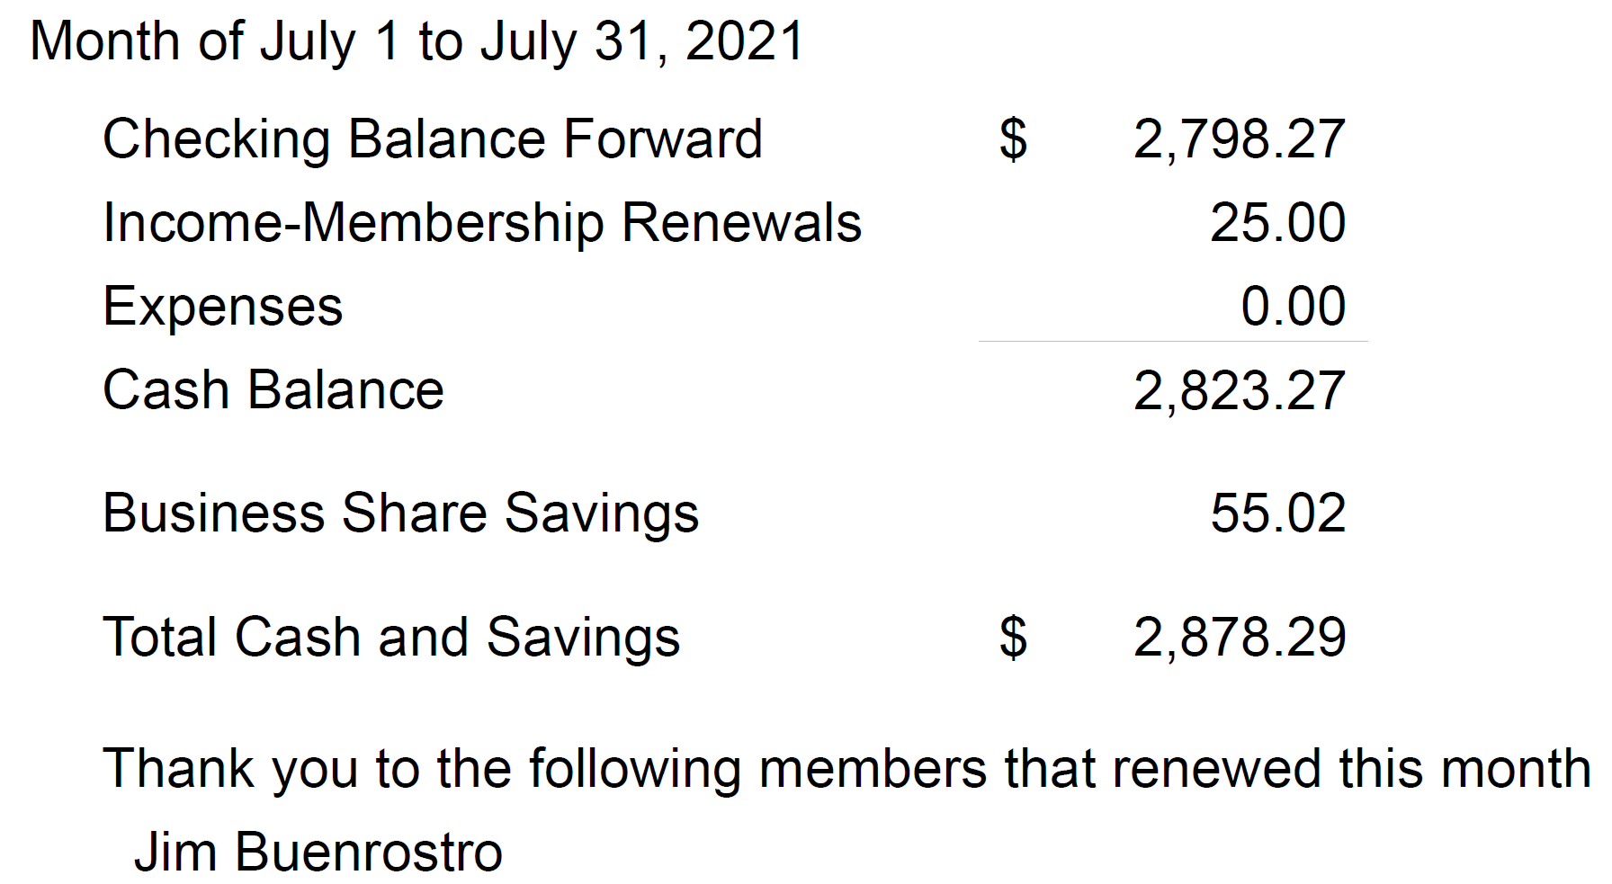
Kaye Raul
▫▫▫▫▫▫▫▫▫▫▫▫▫▫▫▫▫▫▫▫▫▫▫
Photo Group Report by Ralph Sutter
Meeting of 08//08/2021
TOPIC: Textures
In the First Segment, Connie Sutter shared her Notes on Texture as it applies to photos and paintings.
Texture Notes
by Connie Sutter
Texture- Visual Arts
perceived surface quality of work of art
element of 2D & 3D perceived visual & physical properties
conveys messages & emotions
Visual texture | Tactile texture
shiny, speckled | Smooth, wavy
Infer depth in 2D
slant

Infer
smooth/rough
soft/hard
matt/glossy

Natural Texture:
wood, sandpaper, canvas, rocks, glass, granite, metal
brush strokes in painting create texture to see/feel
buildup of paint on surface making actual texture is called impasto
1 hard/soft
2 woven/bumpy
3 jagged/irregular
4 ridged

Smooth - slick, soft, slimy, glossy
Rough – bumpy, scaly, coarse, sandy, rocky, fuzzy, gritty, lumpy, hairy

Fabric Textures
Ceiling Textures
Wall Texture
Carpet Texture

Ralph Sutter shared footage of his recovered drone that flew away in February 2021 and was returned in August undamaged thanks to the thoughtful individual who returned it.

The Second Segment opened with Ralph offering images of his kayaking trip to the San Juan Islands, WA from July 26-30, 2021 as well as close ups of freeze dried fruits and vegetables

Kaye Raul followed showing scenes from the Betteravia Sugar Processing Plant, along with closeups of succulents and small objects

Connie also moved in close to examine the texture of countertops, cabinet sides, furniture and window shades

Stanford Brown followed suit with textures seen on quilts, walls, carpet, garden stones and fabric.

The Third Segment elicited minimal discussion. Ralph again played footage of his drone’s errant flight for those who joined the session after the video had been played.
Our next meeting will take place on September 12th
The topic is Each One Teach One; Demonstrate a skill that you have learned regarding image editing, whether on a computer or on a smart phone.
The meeting will take place via Zoom.
A Zoom invitation will be e-mailed to Photo Group members shortly before the meeting
The meeting schedule for the remainder of 2021 is as follows
October 10
November 14
December 12
See the Links page for tutorials and other resources
Ralph Sutter
▫▫▫▫▫▫▫▫▫▫▫▫▫▫▫▫▫▫▫▫▫▫▫
Push Library
Look at the PUSH archives, http://www.slobytes.org/push/. This is a repository of articles where you will find tips, product reviews, and personal recommendations contributed by computer clubs across the country.
They are provided courtesy of the Association of Computer User Groups, APCUG, the national organization with which SLO Bytes is affiliated.
The actual PUSH articles are hyperlinked from the index located at
http://www.slobytes.org/push/index.html (All articles on one long page)
http://www.slobytes.org/push/push-condensed.html (Links to PUSH articles by month received)
You can view additional APCUG publications here: http://www.slobytes.org/apcug/index.html
SLO Bytes Bulletin Board
Everyone can read the SLO Bytes Bulletin Board at http://slobytes.org/smf/index.php?board=1.0 but only subscribers can post comments or respond to the posts of others. Despite the usual connotation of subscribe, it costs nothing to join the bulletin board. It is free to all current SLO Bytes members. However, to guard against cyber-mischief by spammers and other ne’er-do-wells, I have disabled self-registration. If you want to be added to the bulletin board, please send your request to me at ralph@rsutter.com.
If you are currently registered with the SLO Bytes Bulletin Board and wish to change your password, you will find a video screen capture of how to do so at
http://www.slobytes.org/documents/change-bb-password.mp4
▫▫▫▫▫▫▫▫▫▫▫▫▫▫▫▫▫▫▫▫▫▫▫
Club Information and Meeting Times
SLO Bytes, a PC Users Group dedicated to educating its members in the use of personal computers, digital devices and software, meets on the first Sunday of each month via Zoom. Zoom credentials are sent to members twice shortly before each meeting. If you are a SLO Bytes member and don’t receive this e-mail, please contact ralph@rsutter.com.
All meetings are open to the public at no cost. A general interest and Q&A session occurs from 12:45 PM to 2:00 PM and guest speaker presentations begin at 2:30 PM. Contact Ralph Sutter (ralph@rsutter.com) or visit slobytes.org for additional information about SLO Bytes and the scheduled presentation. All ideas for speakers or presentation subjects are welcome.
HardCopy is a monthly publication of SLO Bytes PC Users' Group located in San Luis Obispo, California. Information in this newsletter is derived from both our own membership and other PC user group newsletters.
The purpose of this publication is to inform our members of meetings and provide information related to the use of PCs and various operating systems.
Membership dues are $25 per year. Membership entitles you to our monthly newsletter via e-mail, technical assistance comradeship and a voice in the affairs of the club.
▫▫▫▫▫▫▫▫▫▫▫▫▫▫▫▫▫▫▫▫▫▫▫
Outside Special Interest Groups (SIGs)
The Linux Group normally meets via Zoom at 6:30 PM on the first Thursday of the month.
View the web site at www.slolug.com. Contact Alan@alanraul.com for credentials to join the Zoom Session.
The Photography Group normally meets via Zoom beginning at 1:00 PM on the second Sunday of each month. Contact ralph@rsutter.com for credentials to join the Zoom Session.
Visit the website at www.slobytes.org/digital
SLO Bytes Officers/Volunteers
Officers
Earl Kaplan – President: earlkaplan@gmail.com
John Waller - Vice President; Programs Chair/Publicity: johnlwaller@sbcglobal.net
Kaye Raul – Treasurer; Membership: kaye@kayeraul.com
Ralph Sutter – Secretary, Webmaster/HardCopy Editor, Photo Group Leader: ralph@rsutter.com
Alan Raul – Training Officer/Linux Group Leader: alan@alanraul.com
▫▫▫▫▫▫▫▫▫▫▫▫▫▫▫▫▫▫▫▫▫▫▫
Disclaimer: Neither SLO Bytes PC Users' Group, its officers, editors, or contributors to this newsletter assume liability for damages arising out of this publication of any article, including but not limited to the listing of programming code, batch
files and other helpful hints. Articles from this newsletter may be reprinted by other user groups if credit is given to both
the author and newsletter from which it was taken. Reproduction of articles with a specific copyright notice is prohibited without prior permission from the original author.
SLO Bytes Website: slobytes.org

