SLO Bytes HardCopy
A publication of the San Luis Obispo PC Users’ Group
Vol. 36 No.12 December 2020
November 1st 2020 First Session Notes by Alan Raul
Download Windows 10 - Update Assistant + Create Windows 10 installation media
https://www.microsoft.com/en-us/software-download/windows10
Extended GodMode - is a utility for easy and quick access to system-level settings. The software is based on the GodMode function of Windows operating systems and complements their capabilities in several ways.
https://www.wintools.info/index.php/extended-godmode
How to Rip an Entire DVD to Your Hard Drive: 6 Simple Steps
https://www.makeuseof.com/tag/5-simple-steps-rip-entire-dvd-hard-drive/
MakeMKV - is your one-click solution to convert video that you own into free and patents-unencumbered format that can be played everywhere.
http://www.makemkv.com/
ODROID-HC4 low-cost dual NAS comes with 4GB RAM, supports 2.5-inch and 3.5-inch SATA drives
https://www.cnx-software.com/2020/10/20/odroid-hc4-low-cost-dual-nas-comes-with-4gb-ram-supports-2-5-inch-and-3-5-inch-sata-drives/
ODROID-HC4
https://ameridroid.com/products/odroid-hc4
How to Share, Embed, and Link YouTube Videos
https://www.lifewire.com/embed-link-youtube-videos-1616995
Examples:
Workshop - Ultimate 2021 Preview Part 1
https://www.youtube.com/watch?v=h65YBSsFGJg&ab_channel=ACDSee
https://www.youtube.com/watch?v=h65YBSsFGJg
https://youtu.be/h65YBSsFGJg
https://youtu.be/h65YBSsFGJg?t=3287
Other Examples:
https://www.fedex.com/apps/fedextrack/?action=track&tracknumbers=914957173264&clienttype=ivother&cmp=EMT-SIRB-SINGLE&ET_CID=4041&ET_RID=51544440
or shortened to
https://www.fedex.com/apps/fedextrack/?action=track&tracknumbers=914957173264
https://www.amazon.com/Logitech-Desktop-Widescreen-Calling-Recording/dp/B004FHO5Y6/ref=sr_1_5?tag=slickdeals&ascsubtag=20225c700f0911eb880d96097eac07130INT&dchild=1&keywords=Logitech%20C270&qid=1601178508&s=electronics&sr=1-5
or shortened to
https://www.amazon.com/Logitech-Desktop-Widescreen-Calling-Recording/dp/B004FHO5Y6/
Why Google Gives Your Searches to Cops
Here is a case for using DuckDuckGo and a VPN.
https://youtu.be/UmAtXoScUAQ
The password problem: How to use 2FA to improve your online security
https://www.zdnet.com/article/how-to-use-an-authenticator-app-to-improve-your-online-security/
ACDSee Luxea Video Editor
RECORD - Import your own footage, work with existing media, or generate your own. Record your webcam, microphone, or screen and add it to your project.
EDIT - Arrange, edit, split, trim, and merge audio, video and still images. Add effects, captions, filters and transitions that make your video stand out.
PRODUCE - Finalize and render your video in a variety of formats and sizes, including 4K. Then share your masterpiece on social media straight from the application.
https://www.acdsee.com/en/products/luxea-video-editor/
Alan Raul
▫▫▫▫▫▫▫▫▫▫▫▫▫▫▫▫▫▫▫▫▫▫▫
November 1st 2020 Second Session Notes
Ralph Sutter placed on line his presentation of Pasting in Word.
View it at https://www.slobytes.org/presentations/sutter-1120/word-paste/word-paste.html
▫▫▫▫▫▫▫▫▫▫▫▫▫▫▫▫▫▫▫▫▫▫▫
December 6th Program by Ralph Sutter

The First ZOOM Session will feature Alan Raul offering a Questions and Answers program from 12:45-2:00 p.m.
Usual topics include security issues, recent changes in Windows operating systems, tablets and smart phones as well as demos of software and hardware. We always encourage questions and observations from the audience.
There will be a break from 2:00-2:30 pm allowing the audience to sip a beverage, pet the dog or stretch
The Second Session, will open with the annual Election of Officers. All SLO Bytes members are encouraged to run for the five seats. They are
President; position currently held by Earl Kaplan
Vice President-Program Chair; position currently held by John Waller
Secretary-Newsletter Editor; currently held by Ralph Sutter
Treasurer; position currently held by Kaye Raul
Training Officer; position currently held by Alan Raul
For a detailed list of responsibilities for each position, see Officer Duties
All of the current Board Members have agreed to continue serving in their present capacity if no other candidates come forward. They have further agreed step aside, helping any new Board Members who may replace them.
The formal program for the Second Session will feature short presentations by Alan Raul, John Waller and Earl Kaplan. Each will offer a 15-20 minute talk on software that they use regularly, keeping in mind the appeal that free software has for many of our members.
To be part of the virtual meeting via Zoom, please refer to the e-mail that will be sent to you twice shortly before the meeting with the credentials necessary to join the Zoom session. If you are asked for a Meeting ID or a Password, copy it from the announcement and paste it into the appropriate box

Contact Ralph at ralph@rsutter.com for more information
View Zoom tutorials at https://www.youtube.com/playlist?list=PLKpRxBfeD1kEM_I1lId3N_Xl77fKDzSXe If you have any questions, please contact ralph@rsutter.com
Ralph Sutter
▫▫▫▫▫▫▫▫▫▫▫▫▫▫▫▫▫▫▫▫▫▫▫

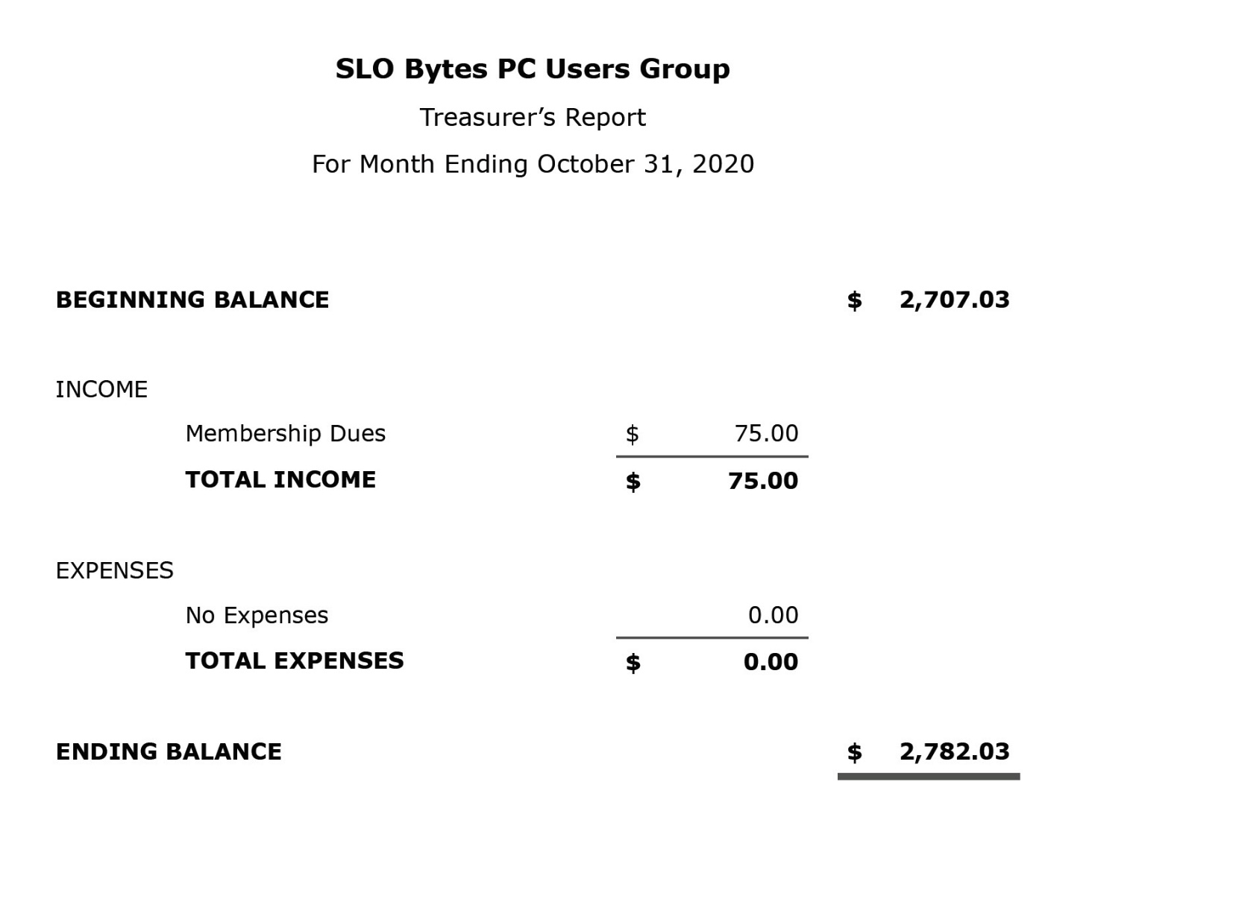
Kaye Raul, Treasurer
▫▫▫▫▫▫▫▫▫▫▫▫▫▫▫▫▫▫▫▫▫▫▫

Photo Group Report by Ralph Sutter
Notes from the Meeting of 11/08/2020
TOPIC: Images Dominated by a Single Color; photos with a single prominent color (Second Installment).
The meeting took place via Zoom
Ralph Sutter opened the meeting, calling attention to the Links Page; https://www.slobytes.org/digital/links.html of the Photography web site.

Sutter then showed close-up images of common items with a single prominent color; a palm tree trunk, rain clouds, expresso accessories and details of watercolors.

Alan Raul followed, offering shots of his annual persimmon harvest. Orange dominated his selections.

Kaye Raul chose the local piers at Pismo Beach and Port San Luis as well as some dramatic sky photos.

John Waller started out close to home, focusing on flowers and emerging grasses before venturing farther afield to water features.

Doug Depue continued to spotlight nuances of color. He sparked a lengthy discussion when he asked if it would be appropriate for him to share some of his voluminous photo library built over many years. The consensus of the other group members was that while it would be ok to offer a limited number of items from the past, we would prefer to see current images, perhaps contrasting his photographer’s eye as it evolved over time.

Ralph made the point shared by several others that while we often use software to alter what comes out of our cameras, Sutter’s goal is to capture a memorable moment in time. That may require nothing more than pressing the shutter at the right time and place with no post-production necessary.

Bob Ward shared a series of photos taken many years ago of the last sawmill in California. Bob captured images of a mill near Shaver Lake, its machinery and the support building in the community that it created.

Our last meeting of 2020 will take place on Sunday, December13th, 2020@ 2:00 pm
The topic will be Shadows; one step behind. The meeting will take place via Zoom

A Zoom invitation will be e-mailed to Photo Group members shortly before the meeting.

See the Links page for tutorials and other resources
Ralph Sutter
▫▫▫▫▫▫▫▫▫▫▫▫▫▫▫▫▫▫▫▫▫▫▫
Push Library
Look at the PUSH archives, http://www.slobytes.org/push/. This is a repository of articles where you will find tips, product reviews, and personal recommendations contributed by computer clubs across the country.
They are provided courtesy of the Association of Computer User Groups, APCUG, the national organization with which SLO Bytes is affiliated.
The actual PUSH articles are hyperlinked from the index located at
http://www.slobytes.org/push/index.html (All articles on one long page)
http://www.slobytes.org/push/push-condensed.html (Links to PUSH articles by month received)
You can view additional APCUG publications here: http://www.slobytes.org/apcug/index.html
SLO Bytes Bulletin Board
Everyone can read the SLO Bytes Bulletin Board at http://slobytes.org/smf/index.php?board=1.0 but only subscribers can post comments or respond to the posts of others. Despite the usual connotation of subscribe, it costs nothing to join the bulletin board. It is free to all current SLO Bytes members. However, to guard against cyber-mischief by spammers and other ne’er-do-wells, I have disabled self-registration. If you want to be added to the bulletin board, please send your request to me at ralph@rsutter.com.
If you are currently registered with the SLO Bytes Bulletin Board and wish to change your password, you will find a video screen capture of how to do so at
http://www.slobytes.org/documents/change-bb-password.mp4
Club Information and Meeting Times
SLO Bytes, a PC Users Group dedicated to educating its members in the use of personal computers, digital devices and software, meets on the first Sunday of each month via Zoom. Zoom credentials are sent to members twice shortly before each meeting. If you are a SLO Bytes member and don’t receive this e-mail, please contact ralph@rsutter.com.
All meetings are open to the public at no cost. A general interest and Q&A session occurs from 12:45 PM to 2:00 PM and guest speaker presentations begin at 2:30 PM. Contact Ralph Sutter (ralph@rsutter.com) or visit slobytes.org for additional information about SLO Bytes and the scheduled presentation. All ideas for speakers or presentation subjects are welcome.
HardCopy is a monthly publication of SLO Bytes PC Users' Group located in San Luis Obispo, California. Information in this newsletter is derived from both our own membership and other PC user group newsletters.
The purpose of this publication is to inform our members of meetings and provide information related to the use of PCs and various operating systems.
Membership dues are $25 per year. Membership entitles you to our monthly newsletter via e-mail, technical assistance comradeship and a voice in the affairs of the club.
Outside Special Interest Groups (SIGs)
The Linux Group normally meets via Zoom at 6:30 PM on the first Thursday of the month.
View the web site at www.slolug.com. Contact Alan@alanraul.com for credentials to join the Zoom Session.
The Photography Group normally meets via Zoom at 2:00 PM on the second Sunday of each month. Contact ralph@rsutter.com for credentials to join the Zoom Session.
Visit the website at www.slobytes.org/digital
▫▫▫▫▫▫▫▫▫▫▫▫▫▫▫▫▫▫▫▫▫▫▫
SLO Bytes Officers/Volunteers
Officers
Earl Kaplan – President: earlkaplan@gmail.com
John Waller - Vice President; Programs Chair/Publicity: johnlwaller@sbcglobal.net
Kaye Raul – Treasurer; Membership: kaye@kayeraul.com
Ralph Sutter – Secretary, Webmaster/HardCopy Editor, Photo SIG Leader: ralph@rsutter.com
Alan Raul – Training Officer/Linux Group Leader: alan@alanraul.com
▫▫▫▫▫▫▫▫▫▫▫▫▫▫▫▫▫▫▫▫▫▫▫
Disclaimer: Neither SLO Bytes PC Users' Group, its officers, editors, or contributors to this newsletter assume liability for damages arising out of this publication of any article, including but not limited to the listing of programming code, batch
files and other helpful hints. Articles from this newsletter may be reprinted by other user groups if credit is given to both
the author and newsletter from which it was taken. Reproduction of articles with a specific copyright notice is prohibited without prior permission from the original author.
SLO Bytes Website: slobytes.org

