Sutter PortableApps Presentation - 08/03/14
PortableApps website: www.portableapps.com
Download Tab: http://portableapps.com/download
Features Tab: http://portableapps.com/platform/features
Apps Tab: http://portableapps.com/apps
Forums: http://portableapps.com/forums
This open source freeware is truly portable. When you copy it to another location, it still works even though the files are in a different location than before.
What is a portable app? http://portableapps.com/about/what_is_a_portable_app
The PortableApps.com Platform™ is a full-featured portable software system that ties all your portable apps together and lets you build your own custom portable app suite for use on your USB drive, cloud drive, or local PC. Use it instead of your own collection of portable apps because
1. It’s more convenient
2. The applications automatically update
Give the example of my slideshow presentation at the Photo SIG.
I needed VLC to show Indian Arm Final.avi Rather than search for it on the host computer, I used the portable version of VLC from my flash drive.
Use Portable Irfanview for another member’s slide show because my version is configured to display all images full-screen.
Demo some apps
Chrome browser to preserve bookmarks
Thunderbird Mail: Read my mail on this app
Virtual Magnifying Glass
Play music with VLC
(Convert audio format with Fr:eac Portable)
Edit music with Audacity
PicPick Portable for screen capture, scrolling screen capture on
Fullbean NOAA Monthly Page; Two day archive; http://fullbean.com/davis/noaa/2day.php
Color picker, White Board
Demo installation of a new app
(in right PortableApps pane, choose Apps/Get more apps/by category)
Choose Ice Breaker Portable in Games
Uninstall Ice Breaker
Have a PortableApps program fail
Install SIW
Show uninstall of SIW
Show how programs automatically updated:
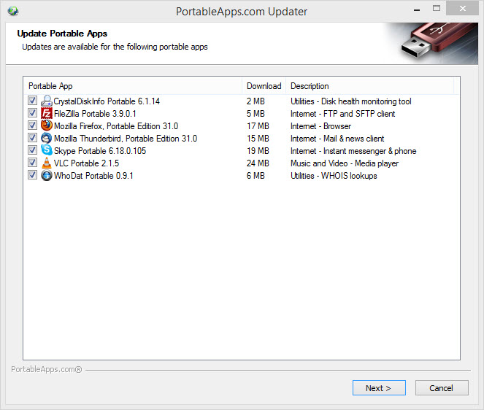

Show screen capture of PortableApps installation: PortableApps.mp4
When you install PortableApps, it creates the following files on your removable device
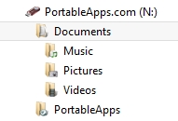
Explain how I created additional files in the documents section
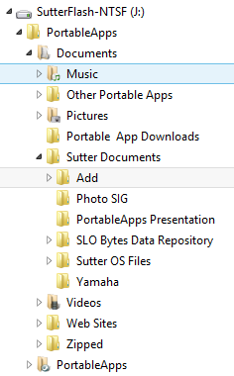
Move PortableApps to another computer and confirm that all of the apps still work as before.

