Sutter PortableApps Presentation - 08/07/16
The PortableApps.com Platform™ is a full-featured portable software system that ties all your portable apps together and lets you build your own custom portable app suite for use on your USB drive, cloud drive, or local PC. Use it instead of your own collection of portable apps because
1. It’s more convenient
2. The applications automatically update
What is a portable app? http://portableapps.com/about/what_is_a_portable_app
PortableApps website: www.portableapps.com
Download Tab: http://portableapps.com/download
Features Tab: http://portableapps.com/platform/features
Apps Tab: http://portableapps.com/apps
Forums: http://portableapps.com/forums
This open source freeware is truly portable. When you copy it to another location, it still works even though the files are in a different location than before.
Screen capture of PortableApps installation http://www.fullbean.com/tutorials/Portable-Apps.mp4
I installed this program to a 16Gb Mushkin drive that I purchased @7.98.
Details at http://www.outletpc.com/fx2241-mushkin-atom-16gb-superspeed-usb-flash-drive.html
When you install PortableApps, it creates the following files on your removable device
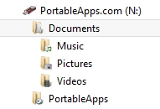
I created additional files in the documents section
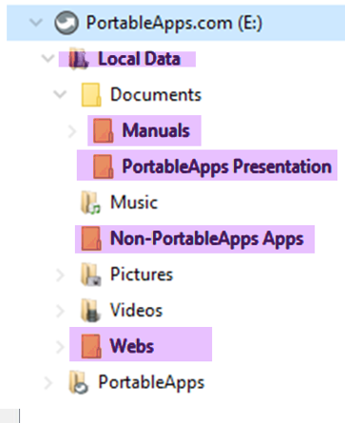
I renamed the PortableApps Documents folder Local Data and inserted some demo files in the folders created
Documents – Presentation notes for today’s talk using Libre Writer Portable
Non-PortableApps Apps
Music – Played Joe Hill with VLC Portable
Pictures – Played images of Cavern Point with Irfanview Portable
Videos – Played SLO Bytes BBQ video with VLC Portable
Webs – SLO Bytes web site files
You can control how the apps are listed, toggling between listing in categories or listing alphabetically. To add apps, click on Apps/Get More Apps from the Taskbar icon. To remove an installed app, right click on the icon for the unwanted app and choose Uninstall.
Every time that you launch PortableApps, it will check to see if updates are available for itself or any installed app.
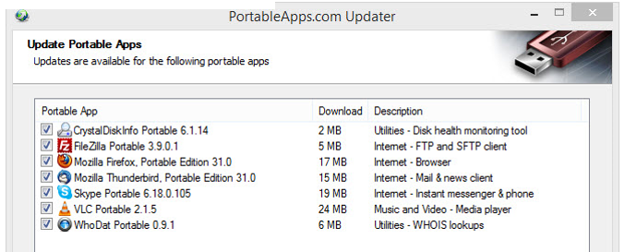
Demo of Irfanview Portable paired with Gimp Portable as an external editor
Irfanview
I often use the program, Irfanvew, to display photographs. I set the program preferences to match how I want the program to work.
Created a slide show from images stored on the PortableApps drive
I have occasionally plugged my PortableApps flash drive with Portable Irfanview into another person’s computer so that I could use Irfanview Portable to create a slide show of that person’s images.
Set up Gimp Portable as external editor on Irfanview
Adjust color of image with Gimp (Create duplicate layer/adjust Brightness and Contrast)
I prefer to use Irfanview to play .mp3 files. This requires a plugin. However, I couldn’t get this to work with Irfanview Portable so I copied to PortableApps the Irfanview folder from my desktop computer. That allowed me to play the .mp3 files. The downside is that this Irfanview installation is not automatically updated as is Irfanview Portable.
Demo of Chrome Portable browser to preserve bookmarks; SLO Bytes web site
Virtual Magnifying Glass
At the close of my presentation, I unplugged the PortableApps flash drive and plugged it into Alan Raul’s computer to confirm that all the functions work on his computer as they did on mine
Ralph Sutter

